

Maintained Secondary Schools and Academies
Fair Access Protocol

2024 – 2025

Contents
1. Main Principles 2
2. Referral to the Fair Access Protocol (FAP) 2
3. IFAP 4
4. Reintegration of pupils from the Tameside Pupil Referral Service (TPRS) 5
5. Local Authority Direction 6
6. Review 6
APPENDIX A – ONLINE FA REFERRAL FORM 7
APPENDIX B – TERMLY SCHOOL FAP REPORT 8
IFAP 2024-2025 Timetable 9

Main Principles
  - The School Admissions Code (2021) requires each Local Authority to have a Fair Access Protocol (FAP) to ensure that unplaced and vulnerable children, and those who are having difficulty securing a place in-year, are allocated a school place so that the length of time any pupil is out of school is kept to the minimum.
  - The guidance states that the Protocol must be developed with all schools in the area, agreed by the majority of schools, and all admission authorities must participate and decisions are binding on all schools.
  - The FAP is maintained and carried out by Tameside’s School Admissions Team.
  - Fair Access Protocols can only be applied to in-year applications and not applications for the normal point of entry (Reception or Year 6 to Year 7 transition).
  - The FAP will ensure that no school or academy, including those with available places, is asked to take a disproportionate number of children and young people who have been excluded from other schools or academies or who have challenging behaviour.
  - Admission Authorities must not refuse to admit a pupil thought to be potentially disruptive, or likely to exhibit challenging behaviour, on the grounds that the child or young person is first to be assessed for special educational needs.
  - Where it has been agreed that an application will be considered under the Fair Access Protocol, a school place must be allocated within 20 school days of receipt of the application. Schools should arrange admission as soon as possible, without unnecessary delay. Where a school is asked to admit and fails to comply, they may be directed to do so.
  - Where the majority of schools and admission authorities in Tameside can no longer support the principles and approach of the Fair Access Protocol, they should initiate a review with the local authority.

Referral to the Fair Access Protocol (FAP)
  - Referral to the FAP should be seen as the last resort to secure a school place for a child. Where possible, children should be placed in school through the usual in-year admissions process.
  - Fair Access Protocols may only be used to place vulnerable and/or hard-to-place pupils who meet the FAP criteria where they are having difficulty in securing a school place in-year AND it can be demonstrated that reasonable measures have been taken to secure a place through normal in-year admissions procedures.
  - Where an admission authority considers that the pupil may fall into a fair access category, the school should notify the Admissions Team of this as soon as possible stating the reasons for referral. An online referral form is shown at Appendix A for this purpose. The form is submitted using this link: https://forms.office.com/e/ta0QgvcCe1
Where the LA subsequently decides that a child is to be placed via the FAP, parents will be notified, and a school place must be allocated to that child within 20 school days.
  - The FAP will only be used to place the following groups of pupils:
    - children either subject to a Child in Need Plan or a Child Protection Plan or having had a Child in Need Plan or a Child Protection Plan within 12 months at the point of being referred to the FAP;
    - children living in a refuge or in other Relevant Accommodation at the point of being referred to the FAP;
    - children from the criminal justice system;
    - children in alternative provision who need to be reintegrated into mainstream education or who have been permanently excluded but are deemed suitable for mainstream education;
    - children with special educational needs (but without an education, health and care plan), disabilities or medical conditions;
    - children who are carers
    - children who are homeless
    - children in formal kinship care arrangements
    - children of, or who are, Gypsies, Roma, Travellers, refugees and asylum seekers;
    - children who have been refused a school place on the grounds of their challenging behaviour and referred to the FAP in accordance with paragraph 3.10 of the Code;
    - children for whom a place has not been sought due to exceptional circumstances (as determined by the Local Authority based on the circumstances of the case)
    - children who have been out of education for 4 or more weeks where it can be demonstrated that there are no places available at any school within a reasonable distance of their home. This does not include circumstances where a suitable place has been offered to a child and this has not been accepted; and
    - previously looked after children for whom the local authority has been unable to promptly secure a school place
  - In most cases, use of the FAP should be unnecessary for a previously looked after child. The LA is expected to secure a school place promptly for such children and for admission authorities to cooperate with this. The LA will consider use of their general powers of direction or will ask the Secretary of State to consider issuing a direction [as set out in paragraphs 3.26 to 3.29 of the Code].
  - Category J, children who display challenging behaviour can be described as where it would be unlikely to be responsive to the usual range of interventions to help prevent and address pupil misbehaviour or it is of such severity, frequency or duration that it is beyond the normal range that schools can tolerate. We would expect this behaviour to significantly interfere with the pupil’s or other pupils’ education or jeopardise the right of staff and pupils to a safe and orderly environment.
  - In Tameside, this can be most likely be considered as children where their behaviour has shown to significantly impact on the learning environment, wellbeing and safety of other pupils and staff over the period of the current academic year.
  - Poor attendance, special educational needs, disability, lack of information and children returning to school from elective home education should not be grounds for considering that a child displays challenging behaviour.
  - The FAP does not apply to looked after children or children with an Education, Health and Care Plan.
  - Schools in Tameside should share good quality pupil information with each other to facilitate pupil transfers and to ensure for better decision-making at IFAPs. Parental consent must be sought before sharing information.
  - A lack of information from a previous school cannot delay the normal admissions process, cannot be a reason for refusing a school place and does not constitute as a reason to refer an application to be considered at IFAP.
  - Where a school is referring an application for consideration at IFAP, they must indicate which criteria of the FAP they believe the application meets which must be evidenced. This must be done at least 3 school days prior to the IFAP.
  - When an application is referred to FAP but is determined to not meet the threshold for any of the criteria, the school is notified and will be instructed to make admission arrangements for any child that has been offered a place.
  - Applications must be referred to IFAP in a timely manner and within the prescribed processing timescales as set out in the Admissions Code.
  - Each school will have a nominated person who is able to provide information on applications in a timely manner.
  - Where an applicant is refused a place at one of their preferred schools, they will be given the right to appeal this decision.

IFAP
  - To accommodate the above requirements, the IFAP will be held every 15 school days, and all schools must participate.
  - Participation includes making available a representative for the school (usually the Headteacher) who is authorised to participate in discussions, make decisions on placing children, and admitting pupils when asked to do so, even when the school is full.
  - Participation also means that schools agree that decisions made are binding and must be adhered to. Non-attendance shall not be cited as a reason to subsequently refuse a place to an allocated pupil.
  - Schools should provide the attached proforma at the start of each term and the information provided, along with FAP allocations for that academic year, will be used to guide the panel on their decision-making.
  - Schools are given credits for each category allocated:
    - Category L – 1 credit
    - All categories except D, L and J – 2 credits
    - Categories D & J – 3 credits
  - The school with the highest number of credits will be considered to have admitted a disproportionate number of pupils. No school should be asked to take a disproportionate number of children who meet the FAP criteria, including schools with places available.
  - If the panel cannot determine which school the pupil will be allocated the chair and the LA representative will determine at the end of the meeting, based on the circumstances of the case and the schools’ information and summary of allocations for that academic year, which school to allocate. This decision is binding.
  - IFAP decisions will be recorded, and schools are expected to arrange admission for any children allocated to them without unnecessary delay.

Reintegration of pupils from the Tameside Pupil Referral Service (TPRS)
  - When there is evidence of progress indicating readiness to return to mainstream school, the TPRS will discuss school options with the child and parents and will offer preference advice.
  - Based on parental preference, previous fair access pupil allocations, geography, transport, and known associations that may hinder success, the TPRS will determine and appropriate school to approach with the intention to allocate and provide pupil information.
  - The requested school will discuss the suitability of the placement with the TPRS within 2 working days from receipt of the information. If the school believes the placement is not suitable, the pupil is referred to be considered at the next IFAP.
  - Once a placement start date is agreed the pupil will be dual registered with the TPRS as the MAIN school and the placement school as the SUBSIDIARY.
  - A meeting for the student and family must be arranged within 5 working days of the agreement and will follow the reintegration script guidelines and will determine:
    - Agreed Start Date
    - Flexible timetable details
    - Examination arrangements
    - Details of learning needs / SEND information /useful strategies for support
    - Medical information sharing
    - Details of other agencies currently involved with the family
    - Review dates for the 4, 8 and 12 week reviews
  - The student will start at their new school within 2 working weeks of the placement agreement.
  - School review meetings will be held at 4, 8 and 12 working weeks. The mainstream school will arrange the review meetings. Representatives from the school, the pupil, their family and TPRS will attend.
  - Following a successful 12-week school review meeting TPRS will take Key Stage 3 students off roll and the student will become single registered at the mainstream school. Key Stage 4 pupils (i.e., Y10 & Y11) remain dual registered until the end of Year 11. For KS4 students who remain dual registered with TPRS, attendance will continue to be monitored by both the mainstream school and TPRS. TPRS will gather attendance data half termly along with details of any action taken for poor attendance. This information must be freely available to TPRS. TPRS will also claim dual registered student’s examination results. This information should be shared with TPRS as soon as possible.
  - Reintegration students must be treated as a regular, supported in year transfer. Breaches of the school behaviour code incur the same sanctions as other students and are not reason for placement breakdown. Poor attendance and uniform transgressions are not reasons for placement breakdown. TPRS student supported re-integrations are NOT Managed Moves.
  - During the dual registration period, should the student’s behaviour give significant cause for concern, (i.e., the student’s behaviour would warrant a permanent exclusion in accordance with the school’s own behaviour policy) the placement will be terminated, by agreement.
  - In the event of placement termination, the Mainstream School will complete and forward the Student Profile to TPRS within 5 working days of the decision with full detail of all relevant information.

Local Authority Direction
  - If the In Year Fair Access Panel does not make an allocation of a school place the Local Authority will ‘instruct’ a school or academy to admit the child.
  - If a school or academy refuses to adhere to a direction from the Local Authority, they must put their reasons in writing within 5 school days. The Local Authority will then decide whether to issue a direction (maintained schools) or refer the matter to the Education Funding Agency acting on behalf of the Secretary of State (all other schools and academies) using the processes outlined in the School Admissions Code (2021).

Review
  - Implementation of the Protocol will be monitored by the Tameside School Admissions Team. The Protocol will be reviewed in the summer term of each academic year so that any amendments can be agreed and implemented from the start of the following academic year.
  - If any parties who are involved with the Fair Access Protocol process feel that the policy is no longer fair or viable, they should submit their concerns in writing to Tameside’s Head of Admissions and Attendance.
  - Should a change to the fundamental principles or the process be proposed, all secondary schools in Tameside will be consulted and invited to express their views.

APPENDIX A – ONLINE FA REFERRAL FORM
LINK: https://forms.office.com/e/ta0QgvcCe1
A short version of the form is below for reference purposes only.
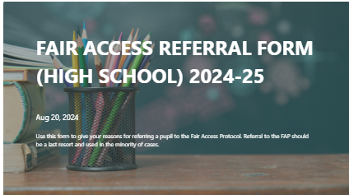
1. Your name
2. Your School Name
3. Pupil Name
4. Pupil’s Year Group
5. Please select the Fair Access Category you consider this application to meet:
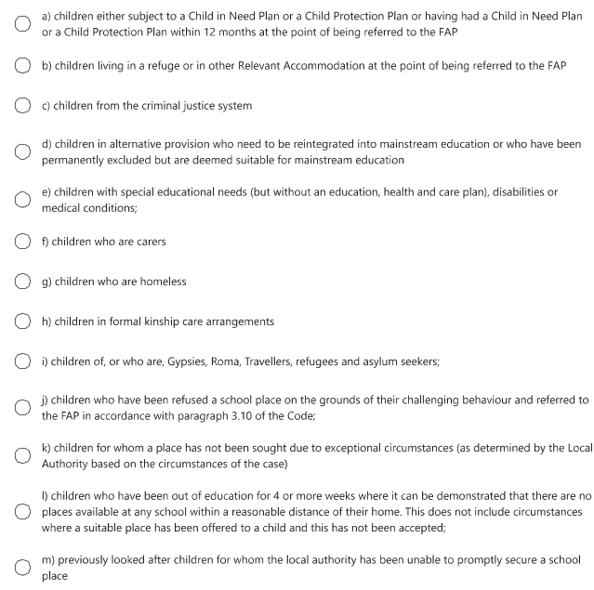
6. School Position - Describe the circumstances preventing you from offering a place to this pupil
7. Pupil’s circumstances – Explain with evidence why this pupil should not be offered a place at your school

APPENDIX B – TERMLY SCHOOL FAP REPORT

School: |  |  |  |  |  | Term: |  |  | Completed by:
 | PAN | NOR | LAC/ PLAC | EHCP | SEN Support | PEX Re | CIN, CPP | FT Susp |  | FAP placed | IY placed | Severely absent
Year 7:
Year 8:
Year 9:
Year 10:
Year 11:
Total:
Additional comments:

IFAP 2024-2025 Timetable

Wednesday 25th September 2024
Wednesday 16th October 2024
Wednesday 13th November 2024
Wednesday 4th December 2024
Wednesday 15th January 2025
Wednesday 5th February 2025
Wednesday 5th March 2025
Wednesday 26th March 2025
Wednesday 30th April 2025
Wednesday 11th June 2025
Wednesday 2nd July 2025

