Service Aims  The VI Service aims to ensure equal access to education for pupils with a vision impairment and endeavours to equip young people with strategies, skills and knowledge that promote independence in learning and life.  Working in Partnership  The Vision Impairment Service works in partnership with families and schools offering support, advice and information regarding vision loss. We liaise with professionals such as  Orthoptists, Ophthalmologists, Integrated  Services for Children with Additional Needs  (ISCAN), Pupil Support Services, Portage,  Educational Psychologists and other agencies*.  *with permission, in line with GDPR guidelines.  Tameside Vision Impairment Service  Ryecroft Hall  Manchester Road  Audenshaw  M34 5ZJ  0161 342 4029  Teacher in Charge: Karen Barton  Karen.barton@tameside.gov.uk  www.tameside.gov.uk  VI Website https://www.tameside.gov.uk/socialcare/tamesidevi  Local Offer  https://www.tameside.gov.uk/localoffer | Useful Organisations  Royal National Institute of the Blind (RNIB)  www.rnib.org.uk  Henshaw’s Society for the Blind  www.henshaws.org.uk  VICTA  www.victa.org.uk  LOOK  www.look-uk.org  National Blind Children’s Society  www.nbcs.org.uk  Our Kids Eyes  www.ourkidseyes.org  KIDS Mediation Service  http://www.kids.org.uk/send-mediation  Noah's Art  www.noahs-art.co.uk  Guide Dogs  https://www.guidedogs.org.uk/  Family Fund (Helping Disabled Children)  https://www.familyfund.org.uk/  Nystagmus Network  https://nystagmusnetwork.org/  The CVI Society (Changing perceptions of vision)  https://cvisociety.org.uk/  Scottish Sensory Centre  http://www.ssc.education.ed.ac.uk/  SENDIASS (Special Educational Needs and Disabilities Information Advice and Support Services)  https://www.kids.org.uk/sendiass | 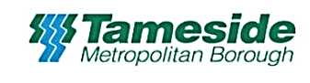  Vision Impairment Service  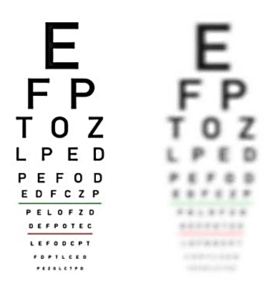  Supporting  Children with a vision impairment

Who are we?  The Vision Impairment (VI) Service supports the  needs of children with vision impairments in  Tameside.  The team provides practical advice and strategies to families, schools and other settings about all aspects of reduced functional vision and its impact on children’s educational, social and emotional development.  We visit children in mainstream and special schools. Younger children are visited in nursery, pre-school and at home.  What is visual impairment?  Visual impairment or low vision is a reduction in vision that cannot be corrected with standard glasses or contact lenses and reduces a person's ability to function at certain or all tasks.  Qualified Teacher of Children with Vision  Impairment (QTVI)  A Qualified Teacher of Children with Vision  Impairment is an experienced Primary/  Secondary teacher who holds a postgraduate qualification in teaching children with vision impairment. | How we support Teachers and Schools  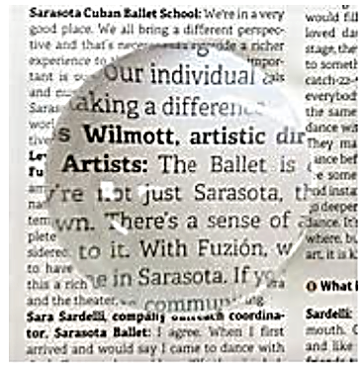  We can:  - Assess the child’s functional vision  - Support transition to pre-school/school/  further education placements  - Write/ create reports, advice sheets and  - programmes of support pending individual  - assessment  - Deliver in-service training  - Plan with teachers and TAs  - Contribute to target setting  - Advise on approaches and strategies  - Advise on adaptation of materials  - Advise on technology and monitor its use  - Advise on examinations and access  arrangements, school trips and work experience  - Respond to queries/concerns and offer  solutions  - Provide on-going training and support for  school staff | How we support Children and Families  We can:  - Help children and their families to understand vision impairment.  - Support families in using assistive technology to help to develop the child’s independence.  - Maintain close contact with families as a source of ongoing advice and to make sure that expectations and approaches are consistent between home and school.  - Signpost parent to supporting charities and organisations.  - Liaise with other agencies to facilitate sharing of information.  - Carry out home visits.  - Attend eye appointments with families if required.  - Monitor the development and vision  progress of babies and young children  from birth to three years of age through the Developmental Journal for Babies and Young Children with Vision Impairment (DJVI).  