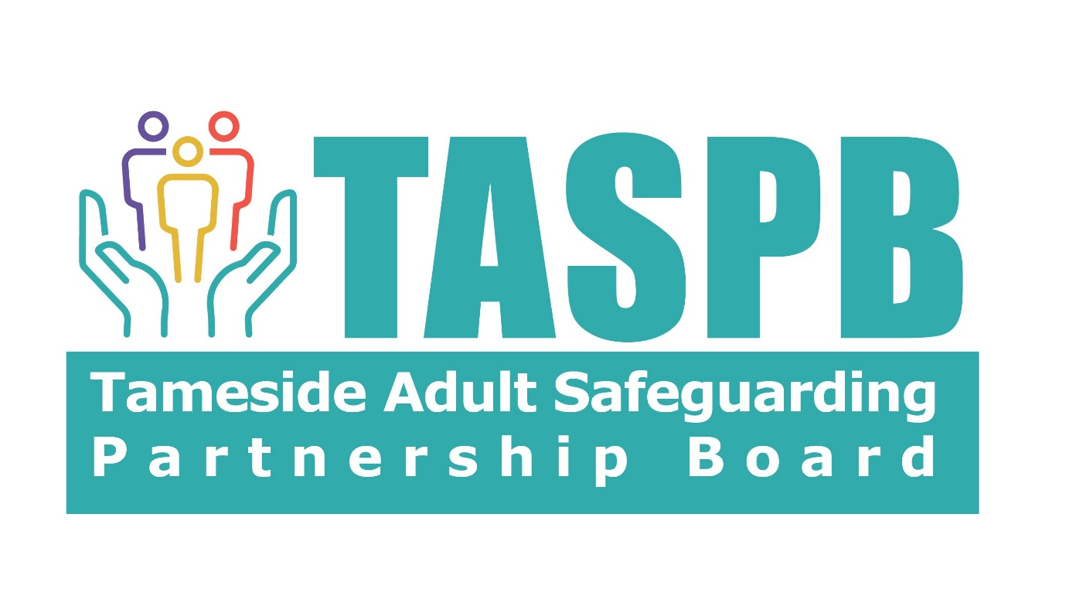
Outcome Meeting Minutes
Name of Adult at Risk:
Date of Meeting
How did the meeting take place?
People Invited | Role/ Relationship | How did they attend
Apologies | Role/ Relationship | Relevant Information Shared
Information About the Person at Risk
Summary of Concerns
Desired Outcomes: Changes the person wants to achieve
Summary of actions taken and findings
Views of relevant parties (Present or not)

Risk assessment: risk to the person and/or others
Safeguarding Plan: What is the plan to manage these risks?
Actions |  | Who will do this? |  |  | When will this be done?
Safeguarding Plan: Arrangements in place to protect others
Action Planned | Times Scales |  | Person/Agency Responsible |  |  | Contact Details
What learning has been identified and how will this be put in to practice:
Actions |  | Who will do this? |  |  | When will this be done?
Does the learning need to be shared with wider organisations? Who is responsible for this action?
Other Actions required:
Actions |  | Who will do this? |  |  | When will this be done?
What are the views of the person at risk (and/or their representative) on these plans? Does the Person at risk feel safer?
Desire outcomes: Have the changes wanted by the person at risk been achieved?
Desired Outcomes of the person at risk: |  |  | Have these been met?
Conclusion of Meeting/ Arrangements for Review (if required)
Since the safeguarding concerns was raised:
Has the risk reduced? |  | Has the risk been removed? |  |  | Does the risk remain?
☐ Yes ☐ No |  | ☐ Yes ☐ No |  |  | ☐ Yes ☐ No
Is a SAR referral required? |  |  |  | Who will be leading this?
☐ Yes ☐ No

Is a Single Agency Review required? | Who will be leading this?
☐ Yes ☐ No
Has the managing the risk protocol been considered?
☐ Yes ☐ No
Comments. :

Name of Enquiry officer leading on enquiry
Or professional leading on Provider lead enquiry:

Date:

