Prodigi – user instructions

- General Prodigi Gestures
- Books
  - Download a book
  - Deleting a book from Prodigi library
- Distance Camera
- Magnifier
- Viewing / reading a document
- Email on the Prodigi

General Gestures

- To return to Main Carousel from anywhere in Prodigi APP, double tap with 2 fingers

- To exit to Android system from Prodigi APP hold 4 or 5 fingers down on screen for couple of seconds

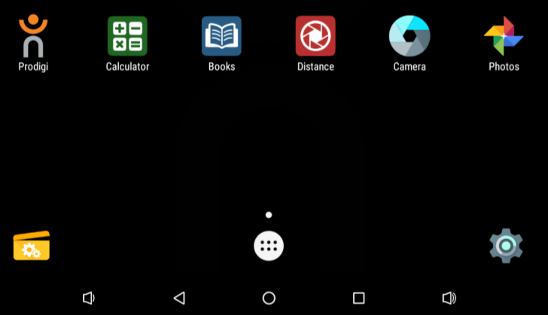
- To go back to Prodigi APP from
Android system either press
Prodigi icon
or
circle at bottom of screen

Books

- RNIB Bookshare login: Prodigi1
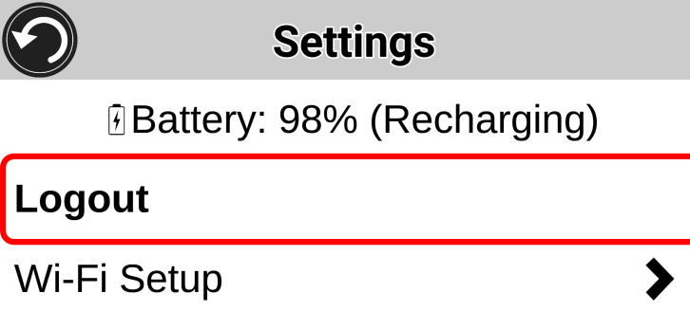
- To open Books Settings menu hold
finger down on back button
for couple of seconds

- Downloading a book
  - In the Books menu select Search Books
  - Select by Title, Author, Category, Content or ISBN
  - When you find a suitable book the book will open on the Prodigi

  - Tot download the book press the Download icon

- Deleting a book from Prodigi library
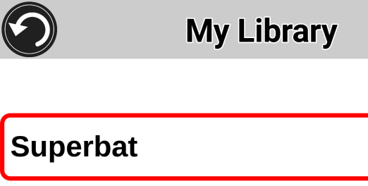
  - Find the book you want to delete

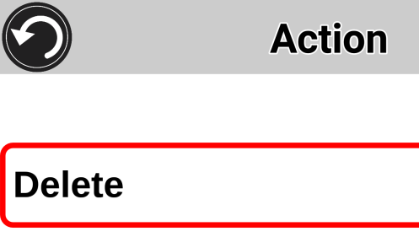
  - Hold finger on name of book for couple of seconds, select Delete

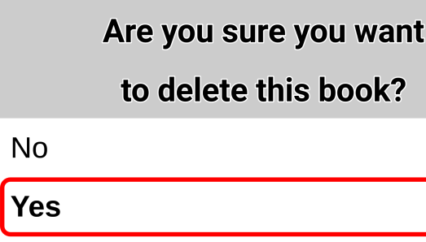
  - Scroll up to highlight “Yes”, and select “Yes”

Distance camera

- Saves images in Gallery / Distance folder
- Images taken with distance camera, which are then saved in Gallery / Distance folder need to be moved to Gallery folder before they can be shared.
To do this:
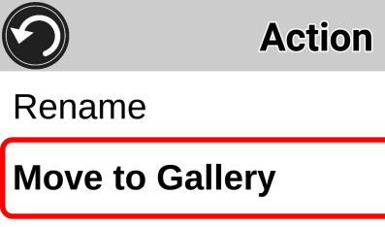
  - Locate image thumbnail in Gallery / Distance folder
  - Hold finger on image for couple of seconds
  - Scroll menu option up to Move to Galley
  - Select this option by selecting with 1 finger press

- Swipe finger up or down right hand side of screen to change between Positive, Negative or Colour mode
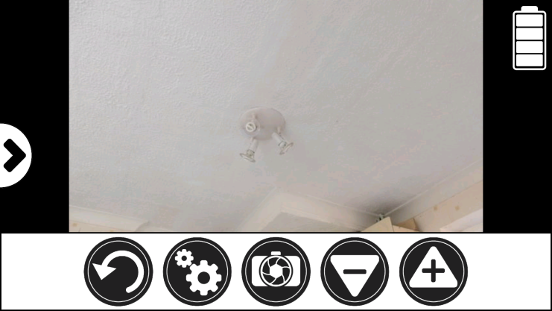
- To split screen between Distance and Magnifier press arrow on left hand side of screen

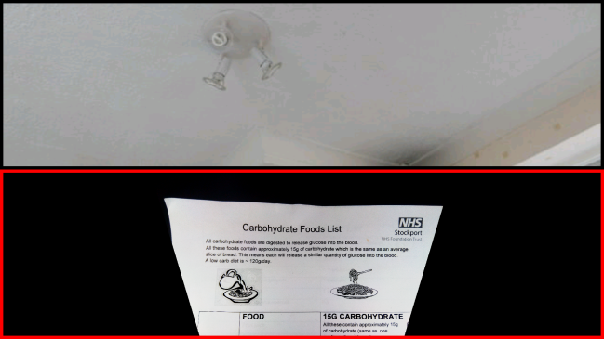
This will create split screen view.

Top half showing distance camera view

Bottom half showing Magnifier

Selecting with single finger press on either view will open full screen to that view.

Magnifier

- Capture image - Hold 1 finger down on screen or press camera icon
- Single images are saved in Gallery / Magnifier folder
- Multi-capture mode
  - Will save in a new folder created within Gallery
    - it will try to set the folder name to text scanned on top line of 1st page
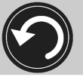
  - When all pages taken press back icon

- Auto Focus lock / unlock - Double tap 1 finger
- Swipe finger up or down right hand side of screen to change between Positive, Negative or Colour
- Swipe finger up or down left hand side of screen to change between Live (Single page) or Multi Capture (multiple pages)
- Full page – use pinch zoom, decrease distance between 2 fingers
- Document can be placed landscape position under magnifier, image should rotate correctly once taken

Viewing / reading a document

- Speech on / off - Double tap with 1 finger for
- Read text - Hold finger down on screen for 2 seconds
- Pause reading - tap Read again or long press anywhere on the screen
- Change reading speed – swipe right with single finger to slow down, left to speed up
- To read from different part in the text
  - Pause reading (long press anywhere on the screen)
  - Press and hold finger for couple of seconds on the word where you want to start reading
- To switch between Page, Column or Line reading modes
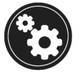
  - Open settings menu
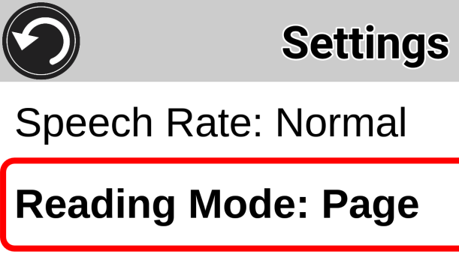
  - Scroll options up to and select
Reading Mode menu
  - Choose desired reading mode

Gallery
- Rename folder - hold finger on folder for Action menu, scroll down menu for 4th option
- Sharing an image / document (e.g. how to email an image or document)
  - Hold single finger down on document until Action menu appears
  - Select Share
  - Choose file format PDF, JPG or Text
  - Select Gmail
  - This will load Gmail APP and allow details including To and Subject to be entered
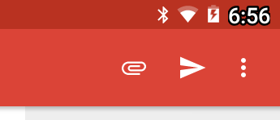
  - Press send icon when ready

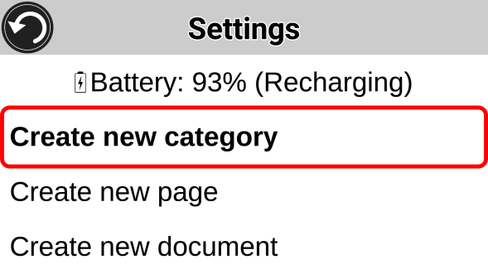
- To open Gallery Settings menu hold
finger down on back button
for couple of seconds

- Images taken with distance camera, which are then saved in Gallery, Distance folder need to be moved to Gallery before they can be shared.
To do this:
  - Locate image thumbnail in Gallery / Distance folder
  - Hold finger on image for couple of seconds
  - Scroll menu option up to Move to Gallery
  - Select this option by selecting with 1 finger press

Email
- Email has been setup using Gmail address ssstprodigi1@gmail.com
- Gmail app can be accessed directly via the Android system, to access this from the Prodigi APP hold 4 or 5 fingers down on the screen for a couple of seconds

