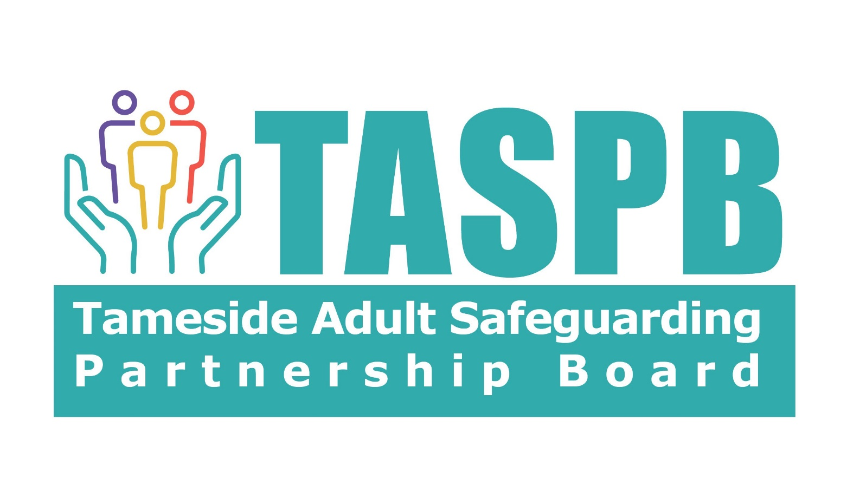

Practitioners Toolkit

Appendix 1: Team Around the Adult Guidance and Templates Pack

Appendix 2: Standard, Moderate and High-Risk Level Fora Overview

Appendix 3: Team Around the Adult (TAA) Meeting Record

Appendix 4: Adult Risk Assessment and Management Tool

Appendix 5: Risk Action Plan (Protection Plan/Intervention/Actions)

Author: Tameside Safeguarding Adults Partnership Board
Adapted by Tameside Policy Procedure Task and Finish Group Policy, Procedure and Workforce Development Sub Group
With thanks to Oldham and Rochdale Adult Safeguarding Board
Adopted: November 2023
Review Date: November 2024
Published Version: 1.0

 |  |  |  |  |  |  | 



