THE TAMESIDE METROPOLITAN BOROUGH
(ARMENTIERES SQUARE AREA, STALYBRIDGE) (RESTRICTED PARKING ZONE & TAXI RANK) ORDER 2026

THE TAMESIDE METROPOLITAN BOROUGH
(ARMENTIERES SQUARE AND BACK GROSVENOR STREET SERVICE AREA)
(LOADING ONLY) ORDER 2026

Tameside Metropolitan Borough Council proposes to make the above Orders under the Road Traffic Regulation Act 1984 the effects of which will be to introduce:-

- A Restricted Parking Zone – No Waiting and No Loading at Any Time (except within authorised parking bays) at (a) Trinity Street, from a point 60 metres north west of its junction with High Street to its junction with Back Grosvenor Street; (b) Back Grosvenor Street, from its junction with Trinity Street to its junction with Armentieres Square; (c) Armentieres Square, from its junction with Back Grosvenor Street to its junctions with Trinity Street and Rose Terrace, (d) Trinity Street from its junction with Armentieres Square to its junction with Corporation Street.

- Authorised Parking Bays limited waiting, 1 hour, Mon – Sat, 8am – 6pm no return within 2 hours at (a) Armentieres Square (west side) from a point 56 metres in a westerly then southerly direction from its junction with Trinity Street, for a distance of 12 metres in a southerly direction; (b) Armentieres Square (west side) from a point 76 metres from its junction with Trinity Street in a westerly then southerly direction for a distance of 18 metres in a southerly direction; (c) Back Grosvenor Street (south side) from a point 15 metres west of its junction with Trinity Street for a distance of 38 metres in a south westerly direction.

- An Authorised Taxi Rank (No Waiting, Except Taxis 7pm – 6am) at (a) Back Grosvenor Street (south side), from a point 15 metres west of its junction with Trinity Street for a distance of 38 metres in a westerly direction.

- A Loading Only Area (24 hours) at the Service Area between Armentieres Square and Back Grosvenor Street.

It is proposed to revoke the Loading Only, Monday – Friday, 8am – 6pm, at Trinity Street, from its junction with Corporation Street to a point 5 metres north of the northerly side of Armentieres Square.
A copy of the proposed Orders, plans and statement of reasons relating thereto may be inspected online via http://www.tameside.gov.uk/trafficregulationorders or be sent to you at your request by e-mailing highwayenquiries@tameside.gov.uk and asking for the Armentieres Square Area, Stalybridge deposited documents.

Objections or comments to the proposals stating the grounds on which they are being made must be submitted in writing to the undersigned or by e-mail to highwayenquiries@tameside.gov.uk by no later than 23 July 2026 , full name and postal address must be included. Objections may be published. If you wish to discuss the proposals, please contact Joanne Biddle, Senior Engineer, on 0161 342 2879.

Date: 25 June 2026

E Varnam; Assistant Director of Environment; PO Box 317, Market Place, Ashton-under-Lyne, OL6 6BH

Statement of Reasons

Following the award for Stalybridge of £19.9 million in funding from the Government’s Capital Regeneration Projects programme a Strategy and Framework was developed and adopted to outline the vision and projects that the money would be spent on, with consultation from residents and stakeholders. Of that funding, £6.1 million has been allocated for improving the public realm in Stalybridge, inclusive of highway improvement works.

The delivery strategy is set out in the Stalybridge Town Centre Framework which was adopted in January 2024. The delivery of the projects is being guided and shaped by a Project Board made up of local councillors and a Delivery Group comprising key representatives from the town.

The proposed traffic regulation orders would allow the parking and loading arrangements within the Armentieres Square area to be formalised without the need for traditional painted double yellow lines and white bay markings. This would serve to improve the aesthetics of the area and reduce the ongoing maintenance costs associated with renewal of the road markings.

The proposed Restricted Parking Zone is an area where waiting and loading restrictions apply. In this instance No Waiting and No Loading at Any Time (except within authorised parking bays). The 11 authorised parking bays would be limited waiting (1 hour, Mon – Sat, 8am – 6pm no return within 2 hours), allowing short term parking for multiple visitors to the town centre. With the bays serving as an authorised Taxi Rank between the hours of 7pm – 6am.

The authorised parking bays will be defined by a delineation of carriageway material. The parking bays / taxi rank and loading only area will be signed in accordance with the Traffic Signs Regulations and General Directions 2016.

The 24-hour loading only area would provide a designated space for commercial and delivery vehicles to temporarily park while actively loading or unloading goods and allow for refuse and recycling collections to take place. On the general arrangement drawing the loading only area has been labelled on the key as ‘Footway (New)’ but for the purposes of the loading only order this area is to be treated as carriageway.

Following consultation with local businesses it is proposed to revoke the loading only bay on the west side of Trinity Street, as owing to its size and location the bay is not being utilised.

Informal pedestrian crossing points will also be introduced at strategic locations within the Armentieres Square area to improve connectivity and the pedestrian experience within the town centre.

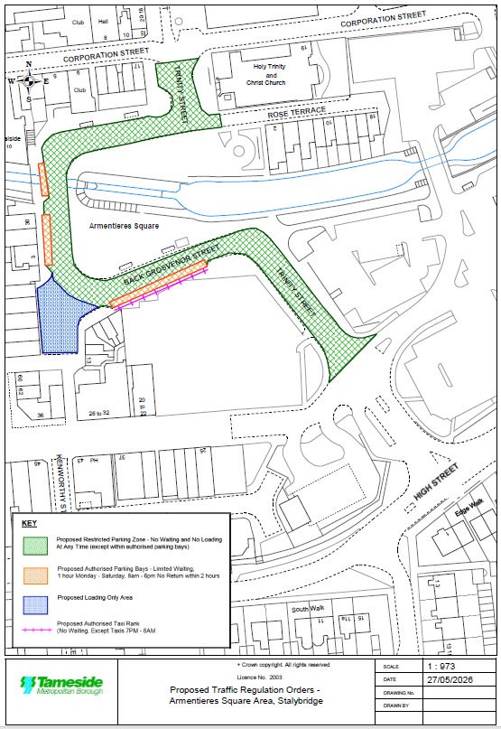

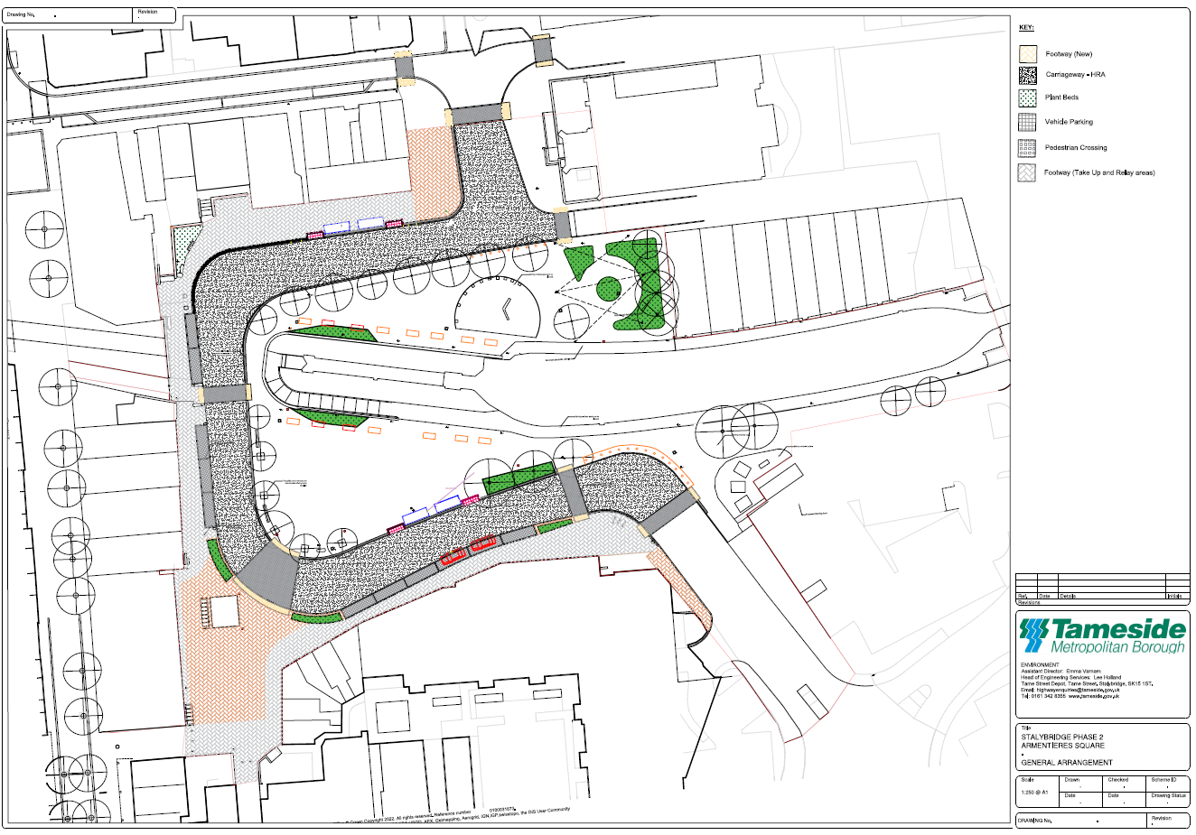

TAMESIDE METROPOLITAN BOROUGH COUNCIL

THE TAMESIDE METROPOLITAN BOROUGH
(ARMENTIERES SQUARE AREA, STALYBRIDGE)
(RESTRICTED PARKING ZONE & TAXI RANK) ORDER 2026

THE TAMESIDE METROPOLITAN BOROUGH COUNCIL in exercise of its powers under Sections 1(1), 2(1) and 2(2) of the Road Traffic Regulation Act 1984 (“the Act”) and of Part IV of Schedule 9 to the said Act of 1984 and of all other enabling powers and after consultation with the Chief Officer of Police in accordance with Part III of Schedule 9 to the Act hereby makes the following Order:-

1. (1) In this Order: -
DRAFT
“restricted parking zone” means lengths of roads in which no waiting and no loading restrictions apply indicated by an entrance sign complying with Schedule 5, Part 3 Item 2 of the Traffic Signs Regulations and General Directions 2016.

“authorised parking place” means any parking place on a road authorised or designated by an Order made or having effect as if made under the Act of 1984; and is indicated by a delineation of carriageway material and a sign complying with Schedule 4, Part 4 Item 2 of the Traffic Signs Regulations and General Directions 2016.

“authorised taxi rank” means an area of carriageway reserved for use by taxis waiting to pick up passengers on a road authorised or designated by an Order made or having effect as if made under the Act of 1984; and is indicated by a delineation of carriageway material and a sign complying with Schedule 4, Part 3 Item 1 of the Traffic Signs Regulations and General Directions 2016.

“taxi” has the same meaning as in Schedule 1 of the Traffic Signs Regulations and General Directions 2016 (or any amendment thereof).

“disabled person’s badge” has the same meaning as in the Disabled Persons (Badges for Motor Vehicles) (England) Regulations 2000.

“disabled person’s vehicle” means a vehicle which displays a disabled person’s badge in accordance with the provisions of the Disabled Persons (Badges for Motor Vehicles) (England) Regulations 2000 as amended, or under any succeeding legislation, and shall include a badge issued under regulations having effect in Scotland or Wales under Section 21 of the Chronically Sick and Disabled Person’s Act 1970, and a recognised badge under Section 21A and B of the 1970 Act.

“parking disc” means a disc issued by a local authority, 125 millimetres square, coloured blue and capable of showing the quarter hour period during which a period of waiting begins.

DRAFT
- For the purpose of this Order a vehicle shall be regarded as displaying: -

- a disabled person’s badge in the relevant position, when: -

- the badge is exhibited on the dashboard or facia of the vehicle so that the front of the badge is clearly legible from the outside of the vehicle or;

- where a vehicle is not fitted with a dashboard or facia, the badge is exhibited in a conspicuous position on the vehicle, so that the front of the badge is clearly legible from the outside of the vehicle.

- a parking disc in the relevant position if;

- the disc is exhibited on the dashboard or facia of the vehicle and shows the quarter hour period during which a period of waiting began and that period is clearly legible from the outside of the vehicle or;

- where the vehicle does not have a dashboard or facia, the disc is exhibited in a conspicuous position on the vehicle, so that, when marked to show the quarter hour period during which a period of waiting began and that period is clearly legible from the outside of the vehicle.

- except where otherwise stated, any reference in this Order to a numbered Article or Schedule is a reference to the Article or Schedule bearing that number in this Order.

Subject to the provisions of this Order, each length of road specified in Schedule 1 shall be a part of a Restricted Parking Zone and save as provided in Article 3, 4 and 5 to this Order no person shall except upon the direction or with the permission of a police constable in uniform or of a civil enforcement officer, cause or permit any vehicle to wait at any time on the sides of lengths of roads specified in Schedule 1 to this Order.

Save as provided in Article 5, 6 and 7 to this Order no person shall except upon the direction or with the permission of a police constable in uniform or of a civil enforcement officer, cause or permit any vehicle to wait between the hours of 8:00am and 6.00pm on Monday to Saturday inclusive within the authorised parking place on the sides of lengths of roads specified in Schedule 2 to this Order:-
DRAFT
- for a longer period than 1 hour; or

- if a period of less than 2 hours has elapsed since the termination of the last period of waiting, if any, by that vehicle on the same side of length of road.

Save as provided in Article 5 to this Order no person shall except upon the direction of or with the permission of a police constable in uniform or a civil enforcement officer, cause or permit any vehicle other than a taxi, to wait on the authorised taxi rank on the sides of lengths of roads specified in Schedule 3 to this Order, between the hours of 7pm – 6am.

(1) Nothing in Articles 2, 3 and 4 shall render it unlawful to cause or permit any vehicle to wait on the sides of lengths of roads referred to therein for so long as may be necessary to enable:-

- persons to board or alight from a vehicle;

- the vehicle, if it cannot conveniently be used for such purpose in any other road, to be used in connection with any of the following operations, namely:-

- building, industrial or demolition operations;

- the removal of any obstruction to traffic;

- the maintenance, improvement or reconstruction of the said sides of lengths of roads; or

- the laying, erection, alteration or repair in, or the land adjacent to, the sides of lengths of roads of any sewer or of any main, pipe or apparatus for the supply of gas, water or electricity or any electronic communications network as defined in the Communications Act 2003.

- the vehicle, if it cannot conveniently be used for such purpose in any other road, to be used in the service of a local authority or any other Authority in the pursuance of statutory powers or duties;
DRAFT

- the vehicle, to be used for the purpose of delivering or collecting postal packets as defined in the Postal Services Act 2000;

- the vehicle to wait at or near to any premises situated on or adjacent to the sides of lengths of roads for so long as such waiting is reasonably necessary in connection with any wedding or funeral; or

- the vehicle to be used for Fire Brigade, Ambulance or Police purposes.

Nothing in Article 3 to this Order shall render it unlawful to cause or permit any vehicle to wait between the hours of 8:00am and 6.00pm on Monday to Saturday inclusive for the purpose of enabling goods to be loaded onto or unloaded from the vehicle on the sides of lengths of roads specified in Schedule 2 to this Order.

Nothing in Article 3 to this Order shall render it unlawful to cause or permit a disabled person’s vehicle which displays in the relevant position a disabled person’s badge, to wait between the hours of 8:00am and 6.00pm on Monday to Saturday inclusive on any of the sides of lengths of roads specified in Schedule 2 to this Order.

THE TAMESIDE METROPOLITAN BOROUGH (CASTLE STREET & GROSVENOR STREET AREA, STALYBRIDGE) (PROHIBITION AND RESTRICTION OF WAITING AND LOADING ONLY) ORDER 2018 shall have effect as though Schedule 1 to that Order is amended in so far as the following sides and lengths of road was deleted therefrom: -

Trinity Street  (both sides) |  | From a point 70 metres north west of its junction with High Street to its junction with Corporation Street
Back Grosvenor Street  (south side) |  | From its junction with Trinity Street for a distance of 13 metres in a westerly direction.
Back Grosvenor Street  (south side) |  | From a point 58 metres west of its junction with Trinity Street to its junction with the Service Area at the junction of Back Grosvenor Street and Armentieres Square.
Back Grosvenor Street  (north side) |  | From its junction with Trinity Street to its junction with Armentieres Square.
Service Area between Armentieres Square and Back Grosvenor Street  (all sides) |  | From its junction with Back Grosvenor Street to its junction with Armentieres Square
Armentieres Square  (west – north side) |  | From a point 20 metres north of its junction with the Service Area at the junction of Back Grosvenor Street and Armentieres Square to its junction with Trinity Street.
Armentieres Square  (east – south side) |  | From its junction with Back Melbourne Street to and including its junction with Trinity Street.
DRAFT
Schedule 3 to that Order is amended in so far as the following sides and lengths of road was deleted therefrom: -
Back Grosvenor Street  (south side) |  | From a point 13 metres west of the junction with Trinity Street for a distance of 45 metres in a westerly direction
Armentieres Square  (west side) |  | From its northerly junction with the service area at the junction with Back Grosvenor Street and Armentieres Square for a distance of 20 metres in a northerly direction (more easily referred to as the lay by to the rear of 40-44 Melbourne Street)

THE TAMESIDE METROPOLITAN BOROUGH (CORPORATION STREET AND TRINITY STREET, STALYBRIDGE) (RESTRICTION OF LOADING) ORDER 2012 shall have effect as though Schedule 1 to that Order is amended in so far as the following sides and lengths of road was deleted therefrom:

Trinity Street  (west side) | - | From its junction with Corporation Street to a point 5 metres north of the northerly side of Armentieres Square.

The prohibitions and restrictions imposed by this Order shall be in addition to and not in derogation from any restrictions or requirement imposed by any regulations made or having effect as if made under the said Act of 1984 or by or under any other enactment.

The Order shall come into operation on the x day of [month][year] and may be cited as “THE TAMESIDE METROPOLITAN BOROUGH (ARMENTIERES SQUARE AREA, STALYBRIDGE) (RESTRICTED PARKING ZONE & TAXI RANK) ORDER 2026

THE COMMON SEAL OF TAMESIDE
METROPOLITAN BOROUGH COUNCIL
was hereunto affixed on the X day of
[MONTH] 2026 in the presence of:
DRAFT
DRAFT

Authorised Signatory

SCHEDULE 1

Restricted Parking Zone – No Waiting and No Loading at Any Time (except within authorised parking bays)
DRAFT
Trinity Street | - |  | from a point 60 metres north west of its junction with High Street to its junction with Back Grosvenor Street.
Back Grosvenor Street | - |  | from its junction with Trinity Street to its junction with Armentieres Square.
Armentieres Square | - |  | from its junction with Back Grosvenor Street to its junctions with Trinity Street and Rose Terrace.
Trinity Street | - |  | from its junction with Armentieres Square to its junction with Corporation Street.
SCHEDULE 2

Authorised Parking Bays limited waiting, 1 hour, Mon – Sat, 8am – 6pm no return within 2 hours

Armentieres Square  (west side) | - |  | from a point 56 metres in a westerly then southerly direction from its junction with Trinity Street, for a distance of 12 metres in a southerly direction.
Armentieres Square  (west side) | - |  | from a point 76 metres in a westerly then southerly direction from its junction with Trinity Street for a distance of 18 metres in a southerly direction.
Back Grosvenor Street  (south side) | - |  | from a point 15 metres west of its junction with Trinity Street for a distance of 37 metres in a south westerly direction.
SCHEDULE 3 |  |  |  | - |  | From a point x metres west of its junction with Trinity Street for a distance of 37 metres I
Authorised Taxi Rank (No Waiting, Except Taxis 7PM – 6AM)

Back Grosvenor Street  (south side) | - | from a point 15 metres west of its junction with Trinity Street for a distance of 37 metres in a westerly direction.  DRAFT

TAMESIDE METROPOLITAN BOROUGH COUNCIL
DRAFT

THE TAMESIDE METROPOLITAN BOROUGH
(ARMENTIERES SQUARE AND BACK GROSVENOR STREET SERVICE AREA)
(LOADING ONLY) ORDER 2026

THE TAMESIDE METROPOLITAN BOROUGH COUNCIL in exercise of its powers under Sections 1(1), 2(1), 2(2), 4(1) of the Road Traffic Regulation Act 1984 (“the Act”) and of all other enabling powers and after consultation with the Chief Officer of Police in accordance with Part III of Schedule 9 to the Act hereby makes the following Order:-

- (1) In this Order:-

“A designated loading area” is a section of carriageway set aside purely for the purposes of loading and unloading, and is comprised within and indicated by a delineation of carriageway material and sign(s) complying with Schedule 5, Part 3, Item 6 of the Traffic Signs Regulations and General Directions 2016.

(2) except where otherwise stated, any reference in this Order to a numbered Article or Schedule is a reference to the Article or Schedule bearing that number to this Order.

- Save as provided in Article 3 to this Order no person shall except upon the direction or with the permission of a police constable in uniform or of a civil enforcement officer, cause or permit any vehicle to wait at any time in the designated loading area except for the purpose of enabling goods to be loaded onto or unloaded from the vehicle within the designated loading area.

- (1) nothing in Article 2 to this Order shall render it unlawful to cause or permit any vehicle to wait in the designated loading area for so long as may be necessary to enable:-

- Persons to board or alight from a vehicle;

- The vehicle, if it cannot conveniently be used for such purpose in any other road, to be used in connection with any of the following operations, namely:-

- Building, industrial or demolition operations;

- The removal of any obstruction to traffic;

- The maintenance, improvement or reconstruction of the designated loading area; or

- The laying, erection, alteration or repair in, or the land adjacent to, the designated loading area of any sewer or of any main, pipe or apparatus for the supply of gas, water or electricity or any electrical communications network as defined in the Communications Act 2003.

- The vehicle, if it cannot conveniently be used for such purpose in any other road, to be used in the service of a local authority or any other Authority in pursuance of statutory powers or duties;
DRAFT

- The vehicle, to be used for the purpose of delivering or collecting postal packets as defined in the Postal Services Act 2000;

- The vehicle to wait at or near to any premises situated on or adjacent to the designated loading area for so long as such waiting is reasonably necessary in connection with any wedding or funeral; or

- The vehicle to be used for Fire Brigade, Ambulance or Police purposes.

- The prohibitions and restrictions imposed by this Order shall be in addition to and not in derogation from any restrictions or requirement imposed by any regulations made or having effect as if made under the said Act of 1984 or by or under any other enactment.

This Order will come into operation on <date> and may be cited as THE TAMESIDE METROPOLITAN BOROUGH (ARMENTIERES SQUARE AND BACK GROSVENOR STREET SERVICE AREA) (LOADING ONLY) ORDER 2026”.

THE COMMON SEAL OF TAMESIDE
METROPOLITAN BOROUGH COUNCIL
was hereunto affixed on the <> day of
<> 2026 in the presence of

Authorised Signatory
SCHEDULE

Loading Only Area – 24 hours

Service Area between Armentieres Square and Back Grosvenor Street (as shown on the enclosed plan)
DRAFT

