 | Who are we?  We support and advocate for children and young people with a deafness within Tameside.  Qualified Teacher of the Deaf (QToD)  Our team includes experienced Primary/Secondary teachers who hold a mandatory postgraduate qualification in Deaf Education. This means that the Qualified Teacher of the Deaf (QToD) will have specialist knowledge about deafness.  Some QToDs also have additional qualifications in Educational Audiology and Early Years and Deafness. All teachers hold level one or above in British Sign Language (BSL).  Specialist Support Assistants (SSAs)  The Specialist Support Assistants (SSAs) work with children and families in nurseries, pre-schools, mainstream schools, specialist provisions, community centres and in family homes around the district. All SSAs have, or are working towards, completing a BSL qualification.  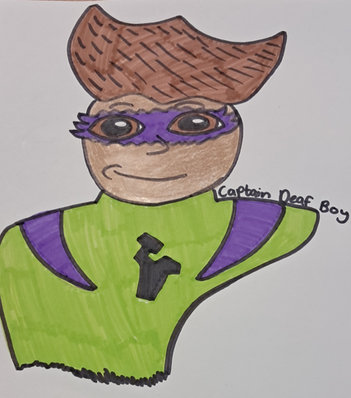  Deaf Resource Base (DRB)  There is a secondary Deaf Resource Base provision in Tameside, and these pupils are mainstream students who access the Deaf Resource Base. This is for their specialist teaching sessions and for audiological support. | 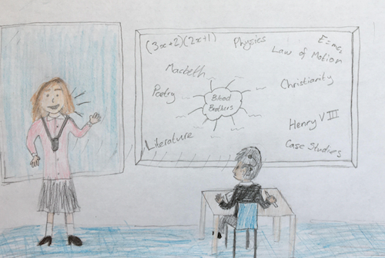  How do we support teachers and schools?  We can:  - Provide specialist teaching and support to pupils with deafness to develop listening and language skills.  - Provide in-service training (INSET) to support school staff in understanding a pupil’s deafness, their equipment and understanding optimal listening conditions.  - Advise school staff on suitable teaching strategies and resources to support an inclusive curriculum.  - Contribute to the assessment and monitoring of pupils’ progress by completing specialist language and listening assessments.  - Provide information and support in regard to access arrangements for examinations.  - Support with transition between key stages and educational settings.  - Offer supervisory support, depending on the needs of the child, comprising of visits to colleges, schools and nurseries to monitor listening ability, check equipment, and offer advice. | How do we support children and families?  We can:  - Help children and their families understand deafness.  - Support families in establishing good hearing technology use and help to develop the child’s independence in maintaining their hearing technology.  - Provide advice and strategies to support and monitor the development of communication and language.  - Support understanding of the different communication methods used by D/deaf learners including speech and sign language.  - Support understanding of the social and emotional impact of deafness.  - Provide support when applying for benefits and services.  - Provide information in regards to the services available from regional and national organisations.  - Liaise with other agencies such as Audiology, Cochlear Implant centre, and Speech Therapy to facilitate sharing of information.  - Provide access to an early years group and signpost to other pre-school groups.  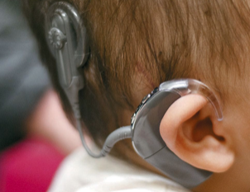
Deaf Education Team  The Tameside Deaf Education Team supports the needs of D/deaf learners and their families from diagnosis until school leaving age. We accept referrals from the Audiology team for newborn babies as well as children who are diagnosed at a later age.  Team Aims  The Deaf Education Team aims to ensure equal access for all pupils with a deafness and endeavours to equip young people with strategies, skills and knowledge that promote independence in learning and life.  Working in Partnership  The Deaf Education Team works in partnership with families and schools offering support and information regarding deafness. We liaise with professionals such as school staff, SENDCo’s, Audiologists, ENT Consultants, health visitors, Speech and Language Therapists, Educational Psychologists, Deaf CAMHs, SEND team and other agencies (with permission, in line with GDPR guidelines).  Local Children’s Audiology Teams-  Paediatric Audiology Service  Tameside General Hospital  Tel: 0161 922 4171  Email: paedshearing@tgh.nhs.uk  Other useful links-  The National Children Deaf Society  National Deaf Children's Society | For every deaf child  RNID  RNID - National hearing loss charity |  | We hope you have found this information helpful. If you have any questions, or would like to talk to someone, please contact us using the details below.  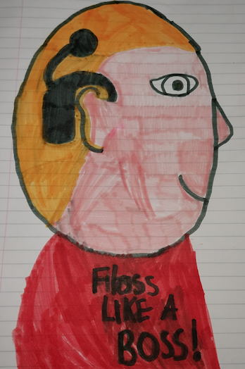  Tameside Deaf Education Team  Ryecroft Hall  Manchester Road  Audenshaw  M34 5ZJ  0161 342 4268  sensory.post@tameside.gov.uk  Local Offer  https://www.tameside.gov.uk/localoffer  Revised: May 2026 |  |   Sensory Support Service    Tameside  Deaf Education Team  ASHTON-UNDER-LYNE – AUDENSHAW - DENTON - DROYLSDEN - DUKINFIELD – HYDE – LONGENDALE - MOSSLEY - STALYBRIDGE

