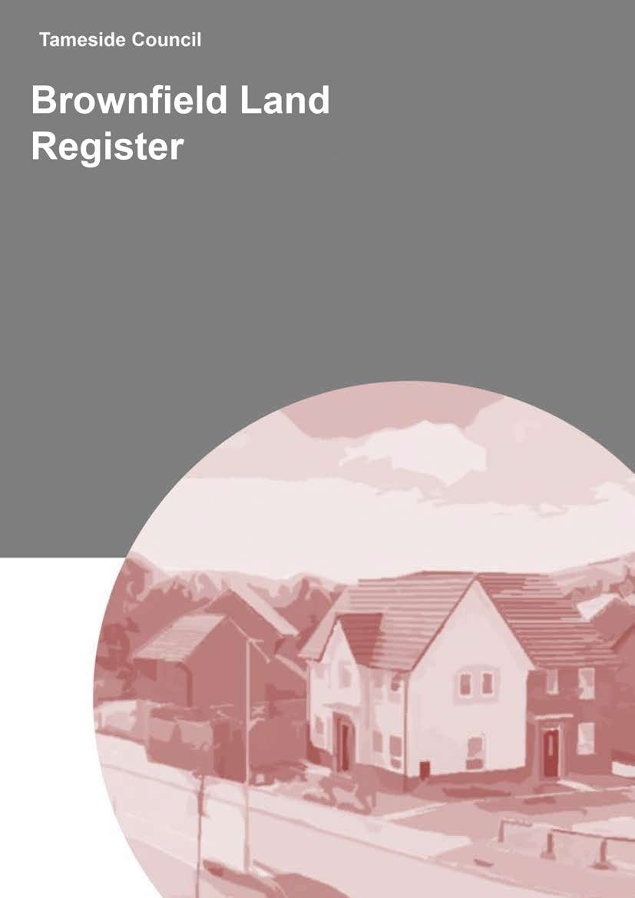


Prepared by

Planning Policy
Tameside Metropolitan Borough Council
PO Box 304
Ashton-under-Lyne
Tameside
OL6 0GA
.............................................................................

Main contributors

Simon Pateman
Laura Smith
Patrick Rushton

……………………………………………………….

Checked By
Graham Holland – Planning Policy Team Manager

Issued By
Daniel Wheelwright – Head of Planning and Transportation

Status

Final Draft

Copyright

Ordnance Survey mapping produced under licence; Crown copyright and database rights 2024 Ordnance Survey 100022697

…………………………………………………………

Document Management

No. Details Date
1.0 Final Publication Version 23.12.2025

Contents

1.0 Introduction ...................................................................................................... 1
2.0 Previously Developed (Brownfield) Land ......................................................... 2
3.0 Methodology .................................................................................................... 2
3.1 Part 1 of the Brownfield Land Register ........................................................ 2
3.2 Part 2 of the Brownfield Land Register ........................................................ 5
4.0 2025 Tameside Brownfield Land Register ....................................................... 6
4.1 Part 1 of the 2025 Tameside Brownfield Land Register ............................... 6
4.2 Part 2 of the 2025 Tameside Brownfield Land Register ............................... 8
5.0 Publication of the 2025 Tameside Brownfield Land Register .......................... 9
Appendix 1 – List of sites in the 2025 Tameside Brownfield Land Register ............. 10
Appendix 2 – Map of sites in the 2025 Tameside Brownfield Land Register ............ 14

1.0 Introduction
1.1 Regulation 3 of the Town and Country Planning (Brownfield Land Register) Regulations 2017 requires each local planning authority in England to prepare, maintain and publish a register of previously developed (brownfield) known as the Brownfield Land Register.

1.2 The purpose of the register is to provide up-to-date and consistent information on brownfield sites that local authorities, such as Tameside, consider appropriate for residential development, having regard to the criteria set out in
Regulation 4 of the Town and Country Planning (Brownfield Land Register) Regulations 2017.

1.3 Planning Practice Guidance was published (28 July 2017) to support local planning authorities in preparing and publishing Brownfield Land Registers (BLRs), together with the brownfield land registers data standard (updated 17 October 2025). Both these documents are available via the following links:

- https://www.gov.uk/guidance/brownfield-land-registers
- https://www.gov.uk/government/publications/brownfield-land-registersdata-standard

  - The BLR consists of two parts: Part 1 comprises all brownfield sites that meet the relevant criteria and are appropriate for residential development; whilst those sites entered into Part 2 of the BLR are granted permission in principle.

  - Local planning authorities are required to update the information relating to each entry and review the sites on their registers at least once a year and are encouraged to conduct more frequent updates of the register where they wish to do so.

2.0 Previously Developed (Brownfield) Land
2.1 Previously developed land, also referred to as brownfield land, is defined in Annex 2 of the (2024) National Planning Policy Framework as:

‘Land which has been lawfully developed and is or was occupied by a permanent structure and any fixed surface infrastructure associated with it, including the curtilage of the developed land (although it should not be assumed that the whole of the curtilage should be developed). It also includes land comprising large areas of fixed surface infrastructure such as large areas of hardstanding which have been lawfully developed. Previously developed land excludes: land that is or was last occupied by agricultural or forestry buildings; land that has been developed for minerals extraction or waste disposal by landfill, where provision for restoration has been made through development management procedures; land in built-up areas such as residential gardens, parks, recreation grounds and allotments; and land that was previously developed but where the remains of the permanent structure or fixed surface structure have blended into the landscape.’

2.2 The BLR guidance states that greenfield land is not appropriate for inclusion in a brownfield land register. It goes on to state that where it is unclear as to whether the whole site is previously developed land, only the brownfield part of the site should be included in Part 1 of the register.

3.0 Methodology

3.1 Part 1 of the Brownfield Land Register
3.1.1 Part 1 of a Brownfield Land Register comprises all brownfield sites that Tameside, as the local planning authority, has assessed as appropriate for residential development.

3.1.2 Criteria 4(1) and 4(2) of the 2017 Regulations are clear that the register must include all brownfield sites at least 0.25 hectares in size, or capable of supporting at least 5 dwellings and that the Council considers to be suitable, available and achievable for residential development. The Council can also choose to include smaller sites in Part 1 of the register but is not obliged to.

3.1.3 Guidance states that the register must include all sites which meet the relevant criteria regardless of their planning status. Therefore, sites with extant full planning permission, outline planning permission and permission in principle that has not been implemented, as well as those sites without planning permission where the local authority has assessed them as appropriate for residential development, will be included within Part 1 of the Tameside register. To note the yield figure in the BLR may differ slightly for some sites when compared to those included in the Strategic Housing and Economic Land Availability Assessment (SHELAA). This is because the BLR estimates total delivery of dwellings on a site and, in some cases, this extends beyond the 15-year period covered by the SHELAA (01 April 2025 - 31 March 2040).

3.1.4 The Brownfield Land Register guidance also advises that local planning authorities should utilise evidence gathered as part of their Strategic Housing Land Availability Assessment (SHLAA) to identify potential sites that maybe suitable for inclusion in a brownfield land register. Tameside have adopted this approach in that information collected from the 2025 SHELAA and previous SHLAAs have been used to identify relevant sites for this BLR update.

3.1.5 Tameside has also taken into consideration the criteria in Regulation 4(2) of the Town and Country Planning (Brownfield Land Register) Regulations 2017 which set out that sites on the register must be:

- ‘Achievable’ in relation to residential development of any land means that, in the opinion of the local planning authority, the development is likely to take place within 15 years of the entry date;
- ‘Available’ for residential development in relation to any land means that the relevant owner or developer has expressed an intention to sell or develop the land and in the opinion of the local authority there are no issues relating to the ownership of the land or other legal impediments which might prevent residential development of the land taking place;
- ‘Suitable’ for residential development, having been allocated in a local development document for residential development; has planning permission for residential development; has grant of permission in principle for residential development; and in the opinion of the local planning authority, appropriate for residential development having regard to any: adverse impact on
- the natural environment or local built environment (including heritage assets) and;
- any adverse impact on local amenity, either for occupiers of the housing or those of neighbouring properties (which presumably could include remaining employment uses); and
- Any relevant representations received.

3.1.6 In addition to the criteria set out above, Local Planning Authorities, such as Tameside are also required to have regard to a range of plans, advice and strategies identified in section 14A (7) of the Planning and Compulsory Purchase Act 2004 including:

  - the development plan;
  - national policies and advice; and

  - any guidance issued by the Secretary of State.

3.1.7 The planning practice guidance goes further to say that this includes development plan documents, Spatial Development Strategies, relevant neighbourhood plans, the National Planning Policy Framework, Planning Practice Guidance, any other guidance published by the Secretary of State, any other relevant statutory requirements and guidance.

3.2 Part 2 of the Brownfield Land Register
3.2.1 Planning practice guidance advises that Part 2 of a brownfield land register is a subset of Part 1. Part 2 will comprise only those sites in Part 1 that the local planning authority has considered to be suitable for a grant of permission in principle for residential development.

3.2.2 Permission in Principle (PiP) has been introduced as an alternative route to gaining planning permission for residential development. The approach separates the approval of principle from that of detail; the latter is covered by the technical details consent stage. Therefore, the process provides certainty on the ‘in principle’ matters of use, location and amount of development rather than using the outline permission process.

3.2.3 The PiP consent route has 2 stages:

- First stage establishes whether a site is suitable in principle for residential development; and
- Second (‘technical details consent’) stage is when the detailed development proposals are assessed.

3.2.4 The scope of permission in principle is limited to location, land use and amount of development. Other matters should be considered at the technical

details consent stage. However, it is worth noting that Part 2 sites will receive permission in principle for a specified range of dwellings and they will need to be advertised and consulted on in a similar way to the development management process.

4.0 2025 Tameside Brownfield Land Register

4.1 Part 1 of the 2025 Tameside Brownfield Land Register
4.1.1 In order to meet the requirement for an annual review, Tameside Council has prepared this 2025 update to Part 1 of its Brownfield Land Register. This review has been directly informed by the Council’s 2025 SHELAA, and as such is a subset of the SHELAA data.

4.1.2 Having regard to the relevant Regulations and guidance outlined in Section 3 of this report, only those sites identified as being wholly brownfield, with the potential to yield five or more dwellings and are not considered to be under construction or complete as of 31 March 2025 are included within the 2025 Tameside BLR. No site with an application submitted after 31 March 2025 will be included within the 2025 BLR, but it will be considered for inclusion within future updates. The Council has also taken the view that greenfield sites and those with a mixture of greenfield and brownfield land should be excluded from the register.

4.1.3 For each site on the register the Council has identified the minimum net number of dwellings that it estimates the site should support. For sites with planning permission this has been given as the number of homes that have been approved as part of that permission; on sites without planning permission the minimum net number of homes is based on an assumption in relation to the potential density of development on each site having regard to

its location etc (in accordance with 2024 Places for Everyone policy JP-H4 Density of New Dwellings).

4.1.4 The Council is also required to identify the maximum number of dwellings a site is capable of supporting where that site does not have planning permission. For simplicity in compiling this register, the Council has assumed that the maximum is the same as the minimum. However, this would not prevent developers from applying for a higher or lower level of housing on any of these sites.

4.1.5 It is not considered that Part 1 of Tameside’s 2025 BLR falls within the scope of the Environmental Assessment of Plans and Programmes Regulations 2004. This is because the Register does not fall within the categories of plans and programmes that require a Strategic Environmental Assessment (SEA) as set out in the SEA Directive and Regulations. Specifically, it does not set the framework for future development consent nor is it required by legislative, regulatory or administrative provisions. The decision that the register does not require SEA will be kept under review.

4.1.6 It should also be noted that the Brownfield Land Register presents only part of the amount of brownfield residential land that is in Tameside. This is because sites that are either under construction and/ or not wholly brownfield in nature are excluded from the register. The SHELAA continues to remain the comprehensive assessment of future housing land supply in the borough and includes dwellings on sites that are excluded from the Brownfield Land Register for reasons set out above.

4.1.7 Using the methodology set out above the Council has identified 96 brownfield sites considered suitable for inclusion within Part 1 of the 2025 Tameside Brownfield Land Register. Based on the analysis of the SHELAA 2025 process it has been determined that these sites have the potential to deliver 3,502 residential units on 41.31 Ha of brownfield land.

4.1.8 The change in the number of sites from 105 and potential site yield of 3,793 dwellings identified within the 2024 BLR can be attributed to the local planning authority’s annual housing land monitoring, which identifies additional sites to be added onto the register and the discounting of sites that are either under construction or where development is complete. Table 1 below identified that sites that have been removed from the 2025 BLR.

Site Reference | Site Name and Address | Hectares | Min Net Dwellings | First Added Date | Removed
H-DENTNE-004 | Premises adjacent to 28 Town Lane, 28 Town Lane,  Denton, M34 5EE | 0.17 | 12 | 31/12/2018 | 31/03/2025
H-DENTNE-075 | Lloyds TSB Bank 38 Ashton Road, Denton | 0.03 | 8 | 31/03/2023 | 31/03/2025
H-DENTNE-080 | Former Denton Centre, Duke Street, Denton | 0.36 | 25 | 01/04/2023 | 31/03/2025
H-DROEST-069 | Moss Tavern site, Moss Tavern, 99-101 Ashton Road,  Droylsden, M43 7FJ | 0.2 | 23 | 31/12/2018 | 31/03/2025
H-DUKSTB-079 | Ashton Weekly Newspapers, Park House 5 Acres Lane,  Stalybridge | 0.2 | 5 | 31/03/2022 | 31/03/2025
H-HYDNEW-003 | Former Newton Printworks (ABC Wax), Clarendon Road,  Hyde, SK14 2LJ | 5.69 | 122 | 31/12/2018 | 31/03/2025
H-HYDWER-011 | Yard & car park on Syddall Street, Syddall Street, Hyde,  SK14 1LB | 0.14 | 10 | 31/12/2018 | 31/03/2025
H-HYDWER-087 | Ground Floor Shirley House Oldham Street, Hyde | 0.03 | 6 | 31/03/2023 | 31/03/2025
H-LONGDE-245 | Roe Cross Green Café, Roe Cross Road, Mottram | 0.13 | 9 | 31/03/2022 | 31/03/2025
H-MOSSLE-132 | North end of Audley Street, Audley Street, Mossley, OL5  9WH | 0.67 | 26 | 31/12/2018 | 31/03/2025
H-STPETE-010 | Car park, 205-217 Stamford Street Central, Ashton-under-  Lyne, OL6 7QB | 0.13 | 35 | 04/12/2017 | 31/03/2025
H-STPETE-024 | 8 Church Street, 8 Church Street, Ashton-under-Lyne | 0.05 | 30 | 04/12/2017 | 31/03/2025
H-STPETE-030 | Fomer Universal Nighclub, 228 Stamford Street Central,  Ashton-under-Lyne, OL6 7LJ | 0.04 | 17 | 04/12/2017 | 31/03/2025
H-STPETE-121 | 6-8 Stamford Arcade, Ashton-under-Lyne | 0.02 | 5 | 31/03/2023 | 31/03/2025
H-STPETE-199 | Cavendish House, Cavendish Street, Ashton-under-Lyne | 0.04 | 6 | 01/04/2023 | 31/03/2025
7.9 339

Table 1: List of sites removed from the 2025 BLR

4.1.9 Appendix 1 provides a list of those sites included within Part 1 of the 2025 BLR, whilst Appendix 2 of this report provides a map identifying the 96 sites included within Part 1 of the BLR.

4.2 Part 2 of the 2025 Tameside Brownfield Land Register
4.2.1 At this time no work has been undertaken by the Council relating to Part 2 of its Brownfield Land Register.
5.1
5
.0

Publication
of the
202
5

Tameside
Brownfield Land
Register

Publication of the Brownfield Land Register takes plac
e through a number of
channels:

•

The Council’s planning web page:

https://www.tameside.gov.uk/planning/brownfieldregiste
r

•

Greater Manchester Combined Authority Mapping:
s
https://mappinggm.org.uk/map

•

Data.gov.uk Open Data:
https://data.gov.uk/dataset/ab455b9
d
-
c2f
2
-
5
441
-
e
b85
-
e
baa5c7e7d75d/tamesid
-
brownfiel
d
-
lan
d
-
registe
r

These will be updated following approval of the Council’s updated
202
5

Brownfield Land Register.

Commented [LP1]:
Will these links need to be
amended?

5.2

Appendix 1 – List of sites in the 2025 Tameside Brownfield Land Register
Site Reference | Site Name Address | Hectares | Min Net Dwellings | First Added Date | Last Updated Date
H-AUDENS-082 | Former Blue Pig PH, Blue Pig, 296-298 Audenshaw Road, Audenshaw, M34 5PJ | 0.24 | 11 | 31/12/2018 | 31/03/2021
H-AUDENS-129 | 218 Audenshaw Road, Audenshaw | 0.18 | 6 | 31/03/2023 | 31/03/2023
H-DENSTH-022 | Former Two Trees School, 101 Two Trees Lane, Denton, M34 7QL | 7.83 | 274 | 31/03/2019 | 31/03/2021
H-DENSTH-031 | Former site of the Old Rectory, Meadow Lane, Denton, M34 7GD | 0.36 | 18 | 04/12/2017 | 31/03/2021
H-DENTNE-005 | Works building, 88-90 Wilton Street, Denton | 0.29 | 20 | 04/12/2017 | 31/03/2021
H-DENTNE-070 | Former Denton Baths, Victoria Street, Denton | 0.22 | 35 | 31/03/2022 | 31/03/2022
H-DROEST-010 | Land at Burman Street, Burman Street, Droylsden | 0.25 | 13 | 31/12/2018 | 31/03/2021
H-DROEST-013 | Land adjacent to 46 Gorsey Fields, 46 Gorsey Fields, Droylsden | 0.18 | 12 | 04/12/2017 | 31/03/2021
H-DROEST-020 | Dream Centre, King Street, Droylsden, M43 6TR | 0.09 | 7 | 31/12/2018 | 31/03/2021
H-DROEST-025 | Garage land adjacent to 342 Fairfield Road, 342 Fairfield Road, Droylsden, M43 7LN | 0.13 | 9 | 31/12/2018 | 31/03/2021
H-DROEST-038 | Land on the corner of King Street and Market Street, King Street, Droylsden, M43 6DQ | 0.07 | 5 | 31/12/2018 | 31/03/2021
H-DROEST-052 | Former Droylsden Library and land west of Lock Keepers Court, Manchester Road, Droylsden | 0.93 | 65 | 01/04/2023 | 31/03/2024
H-DROEST-055 | Seamark, Seamark, Edge Lane, Droylsden, M43 6SJ | 2.24 | 143 | 31/12/2018 | 31/03/2021
H-DROEST-098 | The Jolly Carter, 231 Manchester Road, Droylsden | 0.33 | 34 | 01/04/2023 | 31/03/2024
H-DROWST-019 | Works adjacent 189 Manor Road, 189 Manor Road, Droylsden, M35 6PW | 0.08 | 6 | 31/12/2018 | 31/03/2021
H-DROWST-035 | Droylsden Labour Club 100 Manchester Road, Droylsden | 0.04 | 5 | 31/03/2023 | 31/03/2023
H-DROWST-036 | Former Cemetery Maintenance Yard, Manor Road, Droylsden | 0.25 | 12 | 01/04/2023 | 31/03/2024
H-DUKINF-017 | Former site of North Star Public House, Queen Street, Dukinfield, SK16 4LS | 0.09 | 32 | 04/12/2017 | 31/03/2021
H-DUKINF-018 | Garage and showroom at 193 King Street, 193 King Street, Dukinfield, SK16 4TH | 0.18 | 24 | 04/12/2017 | 31/03/2021
H-DUKSTB-002 | Land adjacent 102-128 Sandy Lane, 102-128 Sandy Lane, Dukinfield | 0.4 | 14 | 04/12/2017 | 31/03/2021
H-DUKSTB-023 | Castle Street car park, Castle Street, Stalybridge, SK15 1PD | 0.51 | 130 | 04/12/2017 | 31/03/2021
H-DUKSTB-039 | Site of Wellington Inn, Caroline Street/Bridge Street, Stalybridge, SK15 1PD | 0.15 | 25 | 04/12/2017 | 31/03/2021
H-DUKSTB-062 | Parking area, rear of 1-7 Gloucester Rise, 1-7 Gloucester Rise, Dukinfield | 0.21 | 7 | 04/12/2017 | 31/03/2021
H-DUKSTB-080 | 1 Trinity Street, Stalybridge | 0.05 | 5 | 31/03/2022 | 31/03/2022
H-DUKSTB-088 | Land between Caroline Street and River Tame, Caroline Street, Stalybridge | 0.52 | 85 | 01/04/2023 | 31/03/2024

Site Reference | Site Name Address | Hectares | Min Net Dwellings | First Added Date | Last Updated Date
H-HURST-059 | Thornfield Gorsey Lane | 0.08 | 5 | 31/05/2025 | 31/05/2025
H-HYDGOD-088 | Former Hyde Library Union Street, Hyde | 0.86 | 61 | 31/03/2022 | 31/03/2022
H-HYDGOD-097 | Top Floor 1 - 7 Borough Arcade | 0.04 | 6 | 31/05/2025 | 31/05/2025
H-HYDGOD-110 | Hyde Central Conservative Club, 2 Reynold Street, Hyde | 0.02 | 6 | 01/04/2023 | 31/03/2024
H-HYDNEW-020 | Garage plot on junction of Lovell Drive and Welch Road, Welch Road, Hyde | 0.1 | 7 | 31/12/2018 | 31/03/2020
H-HYDWER-059 | Dress Up and Party, The Showroom, Croft Street, Hyde | 0.03 | 6 | 04/12/2017 | 31/03/2021
H-HYDWER-074 | 68 - 70 Market Street, Hyde, SK14 1ES | 0.02 | 7 | 31/03/2020 | 31/03/2021
H-HYDWER-078 | 1 Syddall Street, Hyde | 0.14 | 19 | 01/04/2023 | 31/03/2024
H-HYDWER-082 | First Floor Shirley House Oldham Street, Hyde | 0.03 | 7 | 31/03/2022 | 31/03/2022
H-HYDWER-089 | 11 Railway Street, Hyde | 0.03 | 7 | 31/03/2023 | 31/03/2023
H-HYDWER-101 | 3 King Edward Road | 0.05 | 5 | 31/05/2025 | 31/05/2025
H-LONGDE-023 | Former Police Station, Atherton Avenue, Hyde, SK14 6NL | 0.21 | 7 | 31/12/2018 | 31/03/2021
H-LONGDE-042 | off Bretland Gardens, Mottram | 0.22 | 11 | 31/03/2023 | 31/03/2023
H-LONGDE-219 | Land adjacent 2 Ashworth Lane, 2 Ashworth Lane, Mottram, Hyde, SK14 6NT | 0.09 | 6 | 04/12/2017 | 31/03/2021
H-LONGDE-253 | Former Longdendale Recreation Centre, Manley Grove | 0.58 | 20 | 01/04/2023 | 31/03/2024
H-MOSSLE-007 | Land and building at 19B Manchester Road, 19B Manchester Road, Mossley, OL5 9PH | 0.19 | 10 | 31/12/2018 | 31/03/2021
H-MOSSLE-011 | Site of River Mill, 6-32 Waggon Road, Mossley | 0.33 | 23 | 04/12/2017 | 31/03/2021
H-MOSSLE-012 | Plevins, Plevins, Cheshire Street, Mossley, OL5 9NG | 3.74 | 187 | 31/12/2018 | 31/03/2021
H-MOSSLE-043 | Land at the Highland Laddie PH, The Highland Laddie, Market Street, Mossley, OL5 0ES | 0.13 | 6 | 31/12/2018 | 31/03/2021
H-MOSSLE-077 | Land between Station Road and Audley Street, Audley Street, Mossley | 0.24 | 17 | 04/12/2017 | 31/03/2021
H-MOSSLE-096 | Former Mossley Hollins High School, Huddersfield Road, Mossley, OL5 9DJ | 1.91 | 50 | 04/12/2017 | 04/12/2017
H-MOSSLE-130 | Britannia Mill, Britannia Mill, Manchester Road, Mossley, OL5 9AJ | 0.41 | 62 | 04/12/2017 | 31/03/2021
H-MOSSLE-131 | Britannia New Mill, Britannia New Mill, Queen Street, Mossley, OL5 9AL | 1.04 | 73 | 04/12/2017 | 31/03/2021
H-MOSSLE-139 | Former Drill Hall, Manchester Road, Mossley, OL5 9AJ | 0.27 | 6 | 04/12/2017 | 31/03/2021
H-MOSSLE-146 | Yorkshire Ward Conservative Club, Yorkshire Ward Conservative Club, Carrhill Road, Mossley, OL5 0BL | 0.21 | 11 | 31/12/2018 | 31/03/2021
H-MOSSLE-158 | Junction Garage, Junction Garage, Mossley Road, Mossley, OL6 9BQ | 0.27 | 10 | 04/12/2017 | 31/03/2021
H-MOSSLE-178 | Scout Green Depot, 27 Manchester Road, Mossley, OL5 9QW | 0.87 | 55 | 04/12/2017 | 31/03/2021
H-MOSSLE-198 | Fleece Inn 53 Stamford Street, Mossley, OL5 0HR | 0.02 | 5 | 31/03/2021 | 31/03/2021
H-STANTH-029 | St James Church Yard And Memorial Gardens, Huddersfield Road, Millbrook | 0.5 | 23 | 31/03/2021 | 31/03/2021

Site Reference | Site Name Address | Hectares | Min Net Dwellings | First Added Date | Last Updated Date
H-STANTH-032 | Harrop Street and Shepley Street, UDP Allocation E2(9), Harrop Street, Stalybridge | 3.7 | 210 | 04/12/2017 | 31/03/2021
H-STANTH-038 | Former Stalybridge Clinic, Stamford Street, Stalybridge, SK15 1JZ | 0.39 | 78 | 04/12/2017 | 31/03/2021
H-STANTH-042 | Union Bank Chambers, Union Bank Chambers, 75-79 Market Street, Stalybridge, SK15 2AA | 0.02 | 6 | 04/12/2017 | 31/03/2021
H-STANTH-043 | Stalybridge Motors, Stalybridge Motors, 111 Stamford Street, Stalybridge, SK15 1LH | 0.11 | 8 | 31/12/2018 | 31/03/2021
H-STASTH-070 | Travellers Call, 26 Wakefield Road, Stalybridge | 0.05 | 7 | 31/03/2023 | 31/03/2023
H-STMICH-013 | Former Miners Refuge Public House, 222 Kings Road, Ashton-under-Lyne, OL6 8HD | 0.08 | 6 | 04/12/2017 | 31/03/2021
H-STMICH-019 | Land between & to the rear of 24-26 Cedar Street, 24-26 Cedar Street, Ashton-under-Lyne | 0.18 | 9 | 31/12/2018 | 31/03/2021
H-STMICH-033 | Garage plot on junction of Botany Lane & Holden Street, Holden Street, Ashton-under-Lyne | 0.23 | 22 | 31/12/2018 | 31/03/2021
H-STMICH-064 | 30 Romney Street, 30 Romney Street, Ashton-under-Lyne | 0.01 | 6 | 04/12/2017 | 31/03/2021
H-STPETE-007 | Parcel of land junction of Delamere St/Wellington Street/Wood Street, Wood Street, Ashton-under-Lyne, OL6 7LZ | 0.08 | 10 | 04/12/2017 | 31/03/2021
H-STPETE-009 | Fomer Hudson Bay Nightclub, 203-203A Stamford Street Central, Ashton-under-Lyne, OL6 7QB | 0.05 | 6 | 04/12/2017 | 31/03/2021
H-STPETE-014 | Land at Hodgson Street/ Wellbeck Street, St Petersfield, Ashton-under-Lyne | 0.31 | 37 | 31/03/2022 | 31/03/2022
H-STPETE-015 | Former Wesleyan Sunday School, 18 Crown Street, Ashton-under-Lyne, OL6 7PQ | 0.03 | 6 | 04/12/2017 | 31/03/2021
H-STPETE-018 | Former Birch Hotel Site, Birch Street, Ashton-under-Lyne, OL7 0DZ | 0.22 | 11 | 04/12/2017 | 31/03/2021
H-STPETE-022 | Goldgem International Ltd, Cavendish Street, Ashton-under-Lyne, OL6 7BF | 0.44 | 53 | 04/12/2017 | 31/03/2021
H-STPETE-028 | Hanover Mill, Hanover Mill, Fitzroy Street, Ashton-under-Lyne, OL7 0TL | 0.17 | 21 | 31/03/2021 | 31/03/2021
H-STPETE-029 | Former Legends PH, 149 Stamford Street, Ashton-under-Lyne, OL6 6DL | 0.05 | 6 | 04/12/2017 | 31/03/2021
H-STPETE-039 | Union Street Car Park, Union Street, Ashton-under-Lyne | 0.63 | 76 | 31/12/2018 | 31/03/2021
H-STPETE-052 | Land corner of Church Street and Grey Street, Grey Street, Ashton-under-Lyne | 0.05 | 7 | 04/12/2017 | 31/03/2021
H-STPETE-053 | Church Street Car Park, Church Street, Ashton-under-Lyne | 0.13 | 16 | 31/12/2018 | 31/03/2021
H-STPETE-056 | Wood Street Car Park, Wood Street, Ashton-under-Lyne | 0.09 | 10 | 31/12/2018 | 31/03/2021
H-STPETE-057 | Wellington Street Car Park, Wych Street, Ashton-under-Lyne | 0.09 | 11 | 31/12/2018 | 31/03/2021
H-STPETE-063 | Works buildings, South Dean Street / Cavendish Street, Cavendish Street, Ashton-under-Lyne | 0.2 | 24 | 31/12/2018 | 31/03/2021
H-STPETE-065 | Territorial Army Barrack, Territorial Army Barrack, Cavendish Street, Ashton-under-Lyne, OL6 7BY | 0.34 | 41 | 31/12/2018 | 31/03/2021
H-STPETE-083 | Wasteland at end of Stelfox Lane, Stelfox Lane, Audenshaw, M34 5HE | 0.17 | 12 | 31/12/2018 | 31/03/2021
H-STPETE-131 | Henrietta Street and Wimpole Street Car Parks, Wimpole Street, Ashton-under-Lyne | 0.56 | 68 | 31/12/2018 | 31/03/2021
H-STPETE-132 | Old Cross Street Car Parks, Old Cross Street, Ashton-under-Lyne | 0.67 | 81 | 31/12/2018 | 31/03/2021
H-STPETE-143 | Advantage House, 156 Oxford Street West, Ashton-under-Lyne, OL7 0NB | 0.04 | 8 | 31/03/2019 | 31/03/2021
H-STPETE-157 | Independent Methodist Church , Independent Methodist Church, Wellington Road, Ashton-unde-Lyne, OL6 6DP | 0.04 | 12 | 31/03/2020 | 31/03/2021
Site Reference | Site Name Address | Hectares | Min Net Dwellings | First Added Date | Last Updated Date
H-STPETE-164 | Ashton Town Centre, Ashton-under-Lyne | 1.08 | 600 | 31/03/2021 | 31/03/2021
H-STPETE-166 | 257 Stockport Road, Ashton-Under-Lyne, OL7 0NT | 0.09 | 8 | 31/03/2021 | 31/03/2021
H-STPETE-170 | 53 Warrington Street, Ashton-under-Lyne | 0.17 | 32 | 31/03/2022 | 31/03/2022
H-STPETE-177 | 30 - 38 Old Street, Ashton-under-Lyne | 0.16 | 49 | 31/03/2022 | 31/03/2022
H-STPETE-184 | 185 - 189, Stamford Street Central, Ashton-under-lyne | 0.05 | 6 | 31/03/2023 | 31/03/2023
H-STPETE-186 | 61 Stockport Road, Ashton-under-lyne | 0.11 | 43 | 31/03/2023 | 31/03/2023
H-STPETE-191 | 147 - 155 Stamford Street Central, Ashton-under-Lyne OL6 6XW | 0.07 | 33 | 01/04/2023 | 31/03/2024
H-STPETE-202 | Former Active Tameside Ashton Swimming Pool, Water Street, Ashton-under-Lyne | 0.54 | 65 | 01/04/2023 | 31/03/2024
H-STPETE-203 | Good Hope Mill Cross Street | 0.05 | 18 | 31/05/2025 | 31/05/2025
H-STPETE-212 | 202 Stamford Street Central | 0.03 | 9 | 31/05/2025 | 31/05/2025
H-WATERL-010 | Land & garages rear of 61-67 Northumberland Avenue, 61-67 Northumberland Avenue, Ashton-under-Lyne | 0.11 | 8 | 31/12/2018 | 31/03/2021
H-WATERL-050 | Park Bridge Works, Park Bridge Works, Park Bridge, Ashton-under-Lyne, OL6 8AW | 1.23 | 43 | 04/12/2017 | 31/03/2021
H-WATERL-072 | Woodman Inn 338 Oldham Road | 0.04 | 5 | 31/05/2025 | 31/05/2025
41.31 3502

Appendix 2
–

Map

of
s
ites
in the
202
5

Tameside Brownfield Land Register

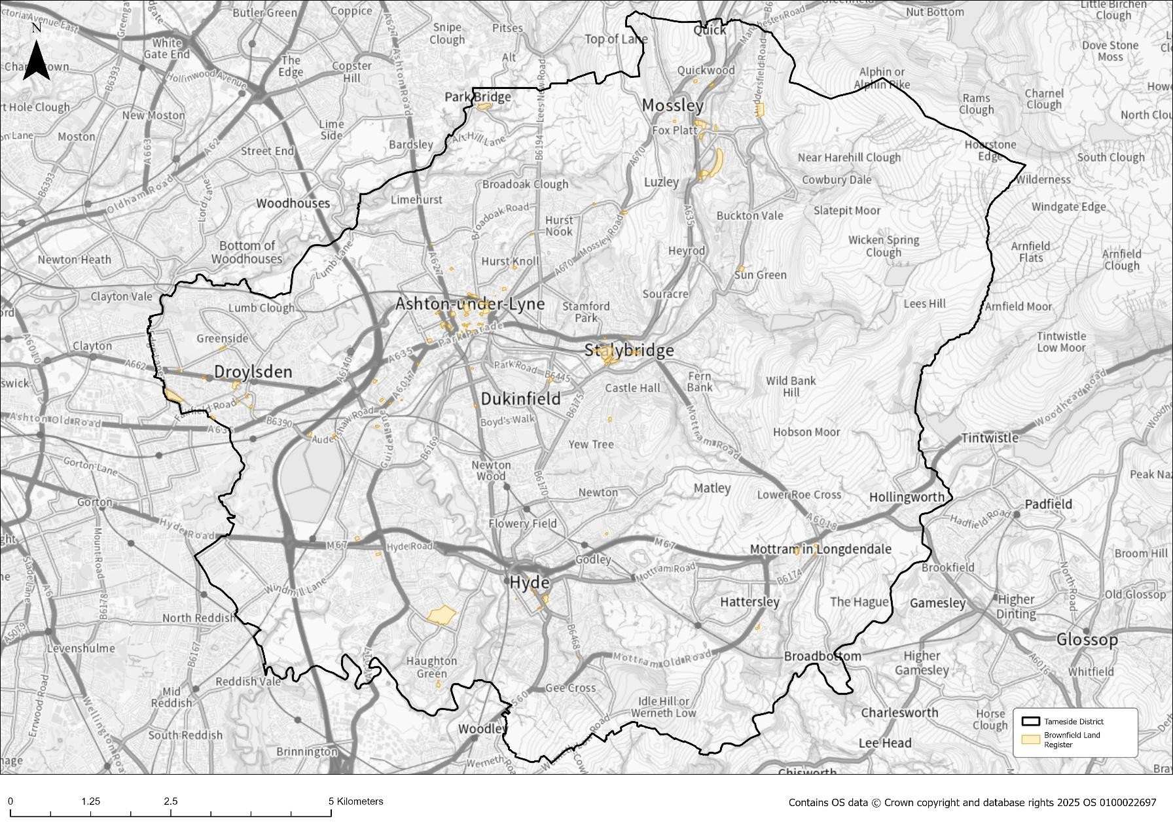

DLUHC & MHCLG (July 2017) Planning Practise Guidance Brownfield Land Registers, Paragraph 001 Reference ID: 59-001-20170728
Regulation 4 The Town and Country Planning (Brownfield Land Register) Regulation 2017
https://www.gov.uk/guidance/permission-in-principle
DLUHC & MHCLG (July 2017) Planning Practice Guidance: Brownfield land register, paragraph 011 Reference ID: 59-011-20170728
Regulation 4 of the Town and Country Planning (Brownfield Land Register) Regulations 2017
(2017) MHCLG & DLUHC, Planning Practice Guidance Brownfield Land Register, Paragraph: 018 Reference ID: 59-018-20170728
DLUHC & MHCLG (July 2017) Planning Practice Guidance: Brownfield land register, paragraph 005 Reference ID: 59-005-20170728 and paragraph 010 Reference ID: 59-010-20170728
DLUHC & MHCLG (July 2017) Planning practice Guidance: Brownfield land register, paragraph 017 Reference ID: 59-017-20170728
https://www.legislation.gov.uk/ukpga/2004/5/section/14A
Planning Practice Guidance: Brownfield land register, paragraph: Paragraph: 009 Reference ID: 59- 009-20170728
DLUHC & MHCLG (July 2017) Planning Practice Guidance: Brownfield land register, Paragraph: 006 Reference ID: 59-006-20170728
DLUHC & MHCLG (July 2017). Planning Practise Guidance: Permission in Principle,
DLUHC & MHCLG (July 2017). Planning Practise Guidance: Permission in Principle, Paragraph: 012 Reference ID: 58-012-20180615
DLUHC & MHCLG (July 2017). Planning Practise Guidance: Permission in Principle, Paragraph: 016 Reference ID: 58-016-20180615

