Request for an Education, Health and Care (EHC) Plan

This is a Child or young person and family contribution. It should be submitted as part of the request for statutory assessment with documents from the referrer.

This document should be completed by the young person and parent / carer together if appropriate AND in partnership with the key worker if parents request it.
Our Hopes and Aspirations

This is a picture of me (Optional)
This can be hand drawn or a photograph sent to us.
We will include this on the front of your plan

My name is:

I like to be known as:

We filled this in on: | Day |  | Month |  | Year

Information about me and my family

Full name |  | Date of birth
Family Contact address |  | Parent/carers names
Gender |  | Please list anyone else with parental responsibility and the relationship to the young person (eg step-dad)
Landline Telephone
Mobile Telephone
Email |  | Brothers and Sisters
NHS number |  | Brothers and Sisters
School Name (or other Educational Setting) |  | Do you need an interpreter or other communication aid? If so, what?
Language used at home |  | Main communication method
Religion |  | Ethnicity:

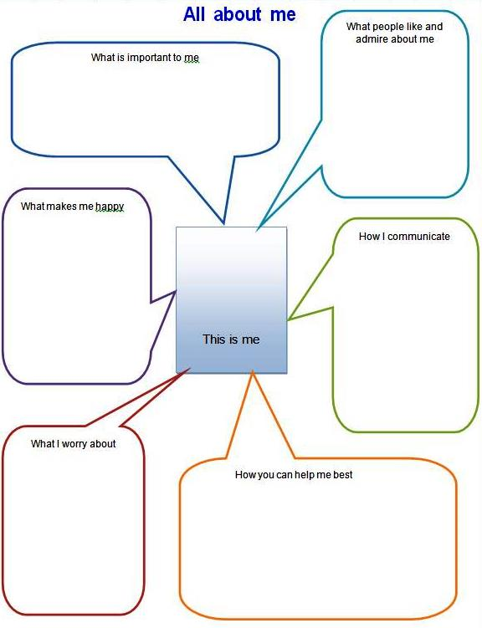

What makes me happy

What is important to me:

How I communicate

What people like and admire about me:



How you can best help me

What I worry about

The important people in my life

(Please give their name, why they were chosen and include photographs if you wish – these might be people in your family, professionals involved or people who have supported you)

Our hopes and aspirations

Tell us what you hope will happen as a result of this assessment.

Our short term aspirations
What I hope for in the next term or so | What my parents / carers hope for in the next term or so

Our medium term aspirations/outcomes

What I hope for in the next year. | What my parents / carers hope for in the next year.

Our long term aspirations/outcomes

What I hope for in the future when I am an adult. | What my parents / carers hope for in the future when I am an adult.

Where my family and I want me to go to learn? (Early years setting, school, college, apprenticeship or training)
How my family and I want me to get to and from my Early years setting, school, college, apprenticeship or training.
Do my family and I want a personal budget? (Information about this can be found on www.tameside.gov.uk/localoffer)
Any other information that my family and I want to share

WHAT TIMES ARE BEST TO CONTACT YOU?
Make a list of the times that are best for you and your family to be contacted, attend appointments or meet professionals.

WHO CAN WE SHARE YOUR INFORMATION WITH?
Make a list below. Include professionals, family members and anyone else that you are happy about.

Signed

Child/young person if appropriate | Parent/carer if young person is under 18 years of age
Date | Date

If you and/or your family need help completing this document please contact your Special Educational Needs Co-ordinator (SENCo) or contact Tameside Special Educational Needs and Disability Information, Advice and Support Service (formerly known as Tameside Parent Partnership Service) on 0161 342 3383.
If this form is completed as part of a re-assessment, a transfer from a Statement of Special Educational Needs to an Education Health Care Plan you and/or your family can contact the Independent Support Service, Together Trust on 07557 801954.

