Statement of Reasons
The reason for the proposed restrictions is to facilitate loading, prevent obstructive parking and reduce congestion on Atlas Street, Ashton-under-Lyne; and to enable better parking turnover on Langham Street, Ashton-under-Lyne.

TAMESIDE METROPOLITAN BOROUGH (ATLAS STREET AND LANGHAM STREET AREA, ASHTON-UNDER-LYNE) (PROHIBITION AND RESTRICTION OF WAITING, LOADING AND LOADING ONLY) ORDER 2023

Tameside Metropolitan Borough Council proposes to make the above Order under the Road Traffic Regulation Act 1984 the effects of which will be to introduce:-

1.) No Waiting and No Loading at Any Time restrictions on: - Atlas Street (north side) from its junction with Oldham Road for a distance of 28 metres in an easterly direction; Atlas Street (south side) from its junction with Oldham Road for a distance of 12 metres in an easterly direction; Atlas Street (south side) from a point 15 metres west of its junction with Minto Street to a point 15 metres east of that junction; Oldham Road (east side) from a point 6 metres south of its junction with Atlas Street to a point 32 metres north of that junction 2.) 30 minutes Limited Waiting between 8am-6pm Monday to Sunday, no return within 1 hour on:- Atlas Street (south side) from a point 12 metres east of its junction with Oldham Road for a distance of 10 metres in an easterly direction 3.) 1 hour Limited Waiting between 8am-6pm Monday to Sunday, no return within 2 hours on:- Langham Street (south side) from a point 15 metres east of its junction with Oldham Road for a distance of 6 metres in an easterly direction 4.) Loading Only Bay – 24 hours:- Atlas Street (north side) from a point 28 metres east of its junction with Oldham Road for a distance of 35 metres in an easterly direction.

A copy of the proposed Order, plan and statement of reasons relating thereto may be inspected online via http://www.tameside.gov.uk/trafficregulationorders or be sent to you at your request by e-mailing trafficoperations@tameside.gov.uk and asking for the Atlas Street/Langham Street Area deposited documents. Objections or comments to the proposals stating the grounds on which they are being made must be submitted in writing to the undersigned or by email to trafficoperations@tameside.gov.uk. The statutory consultation period is 21 days. This has been extended to 28 days ending on the 5 October 2023. If you wish to discuss the proposals please contact Joanne Biddle on 0161 342 2879.

Date: 7 September 2023

E Varnam; Assistant Director of Operations and Neighbourhoods; Tameside One, Market Place, Ashton-under-Lyne, OL6 6BH

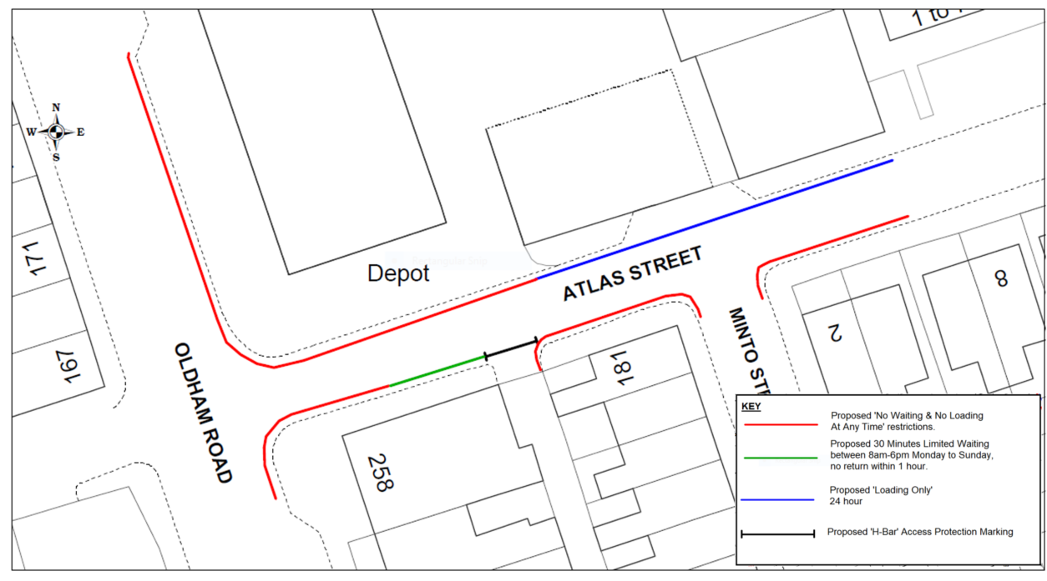

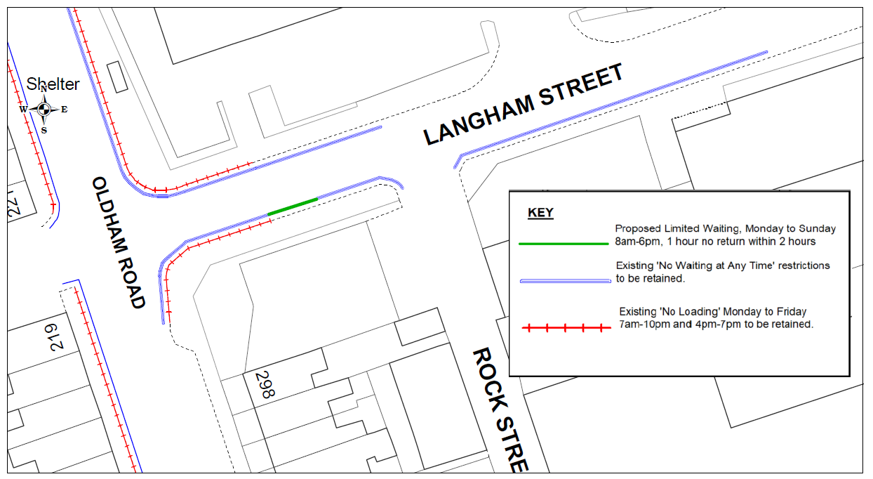

TAMESIDE METROPOLITAN BOROUGH COUNCIL

TAMESIDE METROPOLITAN BOROUGH
(ATLAS STREET AND LANGHAM STREET AREA, ASHTON-UNDER-LYNE)
(PROHIBITION AND RESTRICTION OF WAITING, LOADING AND LOADING ONLY) ORDER 2023

Tameside Metropolitan Borough Council, in exercise of its powers under Sections 1(1), 2(1), 2(2) and 4(2) of the Road Traffic Regulation Act 1984 (“the Act”) and of Part IV of Schedule 9 to the said Act of 1984 and of all other enabling powers and after consultation with the Chief Officer of Police in accordance with Part III of Schedule 9 to the Act hereby makes the following Order:-

1. (1) In this Order:-

“disabled person’s badge” has the same meaning as in the Disabled Persons (Badges For Motor Vehicles)(England) Regulations 2000;

“disabled person’s vehicle” means a vehicle which displays a disabled person’s badge in accordance with the provisions of the Disabled Persons (Badges for Motor Vehicles) (England) Regulations 2000 as amended, or under any succeeding legislation, and shall include a badge issued under regulations having effect in Scotland or Wales under Section 21 of the Chronically Sick and Disabled Person’s Act 1970, and a recognised badge under Section 21A and B of the 1970 Act;
DRAFT

“parking disc” means a disc issued by a local authority, 125 millimetres square, coloured blue and capable of showing the quarter hour period during which a period of waiting begins.

“authorised parking place” means any parking place on a road authorised or designated by an Order made or having effect as if made under the Act of 1984;

“A designated loading bay” is a section of carriageway set aside purely for the purposes of loading and unloading, and is comprised within and indicated by a road marking complying with diagram 1028.4 in Schedule 7, Part 4 of the Traffic Signs Regulations and General Directions 2016; and with a sign(s) complying with paragraphs 9 to 18 of Schedule 4, Part 2 of the Traffic Signs Regulations and General Directions 2016.

- For the purpose of this Order a vehicle shall be regarded as displaying:-

- a disabled person’s badge in the relevant position, when:-

- the badge is exhibited on the dashboard or facia of the vehicle so that the front of the badge is clearly legible from the outside of the vehicle or;

- where a vehicle is not fitted with a dashboard or facia, the badge is exhibited in a conspicuous position on the vehicle, so that the front of the badge is clearly legible from the outside of the vehicle.
- a parking disc in the relevant position if;

- the disc is exhibited on the dashboard or facia of the vehicle and shows the quarter hour period during which a period of waiting began and that period is clearly legible from the outside of the vehicle or;

(ii) where the vehicle does not have a dashboard or facia, the disc is exhibited in a conspicuous position on the vehicle, so that, when marked to show the quarter hour period during which a period of waiting began and that period is clearly legible from the outside of the vehicle.

- except where otherwise stated, any reference in this Order to a numbered Article or Schedule is a reference to the Article or Schedule bearing that number in this Order.

- Save as provided in Article 6 to this Order no person shall except upon the direction or with the permission of a police constable in uniform or of a civil enforcement officer, cause or permit any vehicle to wait at any time on the sides of lengths of roads specified in Schedules 1 and 2 to this Order.
DRAFT
DRAFT
DRAFT
DRAFT

- Save as provided in Article 6 to this Order no person shall except upon the direction or with the permission of a police constable in uniform or of a civil enforcement officer, cause or permit any vehicle to wait between the hours of 8.00am and 6.00pm on Monday to Sunday inclusive on the sides of lengths of roads specified in Schedule 3 to this Order:-

- for a longer period than 30 minutes; or

- if a period of less than 1 hour has elapsed since the termination of the last period of waiting, if any, by that vehicle on the same side of length of road.

- Save as provided in Article 6 to this Order no person shall except upon the direction or with the permission of a police constable in uniform or of a civil enforcement officer, cause or permit any vehicle to wait between the hours of 8.00am and 6.00pm on Monday to Sunday inclusive on the sides of lengths of roads specified in Schedule 4 to this Order:-

- for a longer period than 1 hour; or

- if a period of less than 2 hour has elapsed since the termination of the last period of waiting, if any, by that vehicle on the same side of length of road.

- Save as provided in Article 6 to this Order no person shall except upon the direction or with the permission of a police constable in uniform or of a civil enforcement officer, cause or permit any vehicle to wait at any time on the sides of lengths of road as specified in Schedule 5 to this Order except for the purpose of enabling goods to be loaded onto or unloading from the vehicle within the designated loading bay.

6. (1) Nothing in Article 2, 3, 4 or 5 shall render it unlawful to cause or permit any vehicle to wait on the sides of lengths of roads referred to therein for so long as may be necessary to enable:-

- persons to board or alight from a vehicle;

- the vehicle, if it cannot conveniently be used for such purpose in any other road, to be used in connection with any of the following operations, namely:-

- building, industrial or demolition operations;

- the removal of any obstruction to traffic;

- the maintenance, improvement or reconstruction of the said sides of lengths of roads; or

- the laying, erection, alteration or repair in, or the land adjacent to, the sides of lengths of roads of any sewer or of any main, pipe or apparatus for the supply of gas, water or electricity or any electronic communications network as defined in the Communications Act 2003.

- the vehicle, if it cannot conveniently be used for such purpose in any other road, to be used in the service of a local authority or any other Authority in the pursuance of statutory powers or duties;

- the vehicle, to be used for the purpose of delivering or collecting postal packets as defined in the Postal Services Act 2000;
DRAFT
- the vehicle to wait at or near to any premises situated on or adjacent to the sides of lengths of roads for so long as such waiting is reasonably necessary in connection with any wedding or funeral; or

- the vehicle to be used for Fire Brigade, Ambulance or Police purposes.

- Nothing in Articles 2, 3, 4 or 5 to this Order shall render it unlawful to cause or permit any vehicle to wait for so long as may be necessary for the purpose of enabling goods to be loaded onto or unloaded from the vehicle on the sides of lengths of roads specified in Schedules 1, 3, 4 and 5 to this Order, at any time.

- Nothing in Article 2 to this Order shall render it unlawful to cause or permit a disabled person’s vehicle which displays in the relevant position a disabled person’s badge and a parking disc (on which the driver, or person in charge of the vehicle, has marked the time at which the period of waiting began) to wait on any of the sides of lengths of roads referred to in Schedule 1 to this Order for a period not exceeding three hours (not being a period separated by an interval of less than one hour from a previous period of waiting by the same vehicle on the same side of length of road on the same day)

- Nothing in Articles 4 and 5 to this Order shall render it unlawful to cause or permit a disabled person’s vehicle which displays in the relevant position a disabled person’s badge, to wait on any of the sides of lengths of roads referred to in those Articles

- THE GREATER MANCHESTER COUNTY (A627/A6017), NORTH-SOUTH ROUTE TAMESIDE) (PROHIBITION AND RESTRICTION OF WAITING) (NO.1) (COUNTY) ORDER 1982 shall have the effect as though in Schedule 11, Part 2 to that Order the sides and lengths of roads:

“Langham Street south side from a point 15 metres east of its junction with Oldham Road and the point 135 feet east of its junction with Rock Street” were deleted therefrom.

- THE TAMESIDE METROPOLITAN BOROUGH (OLDHAM ROAD, BETWEEN CRANBOURNE ROAD AND THE NORTHERLY JUNCTION WITH TAUNTON ROAD, ASHTON-UNDER-LYNE) (PROHIBITION OF WAITING AND LOADING) ORDER 2004 shall have the effect as though in Schedule 2 to that Order the sides and lengths of roads:

“Oldham Road, Ashton (east side) from a point 6 metres south of Atlas Street to a point 32 metres north of Atlas Street” were deleted therefrom.

- THE TAMESIDE METROPOLITAN BOROUGH (OLDHAM ROAD, BETWEEN CRANBOURNE ROAD AND THE NORTHERLY JUNCTION WITH TAUNTON ROAD, ASHTON-UNDER-LYNE) (PROHIBITION OF WAITING AND LOADING) ORDER 2004 shall have the effect as though in Schedule 2 to that Order the sides and lengths of roads:

“Atlas Street, Ashton (both sides) from its junction with Oldham Road for 15 metres in an easterly direction” were deleted therefrom.

- The prohibitions and restrictions imposed by this Order shall be in addition to and not in derogation from any restrictions or requirement imposed by any regulations made or having effect as if made under the said Act of 1984 or by or under any other enactment.

The Order shall come into operation on the <DATE> day of <MONTH AND YEAR> and may be cited as TAMESIDE METROPOLITAN BOROUGH (ATLAS STREET AND LANGHAM STREET AREA, ASHTON-UNDER-LYNE) (PROHIBITION AND RESTRICTION OF WAITING, LOADING AND LOADING ONLY) ORDER 2023

THE COMMON SEAL OF TAMESIDE
METROPOLITAN BOROUGH COUNCIL
was hereunto affixed on the <DATE> day of
<MONTH AND YEAR> in the presence of

DRAFT
DRAFT

Authorised Signatory

SCHEDULE 1

No Waiting at Any Time

Langham Street  (south side) | - | from a point 21 metres east of its junction with Oldham Road to a point 41 metres east of its junction with Rock Street.
SCHEDULE 2
DRAFT

No Waiting and No Loading at Any Time

Atlas Street  (north side) | - | from its junction with Oldham Road for a distance of 28 metres in an easterly direction.
Atlas Street  (south side) | - | from its junction with Oldham Road for a distance of 12 metres in an easterly direction.
Atlas Street  (south side) | - | from a point 15 metres west of its junction with Minto Street to a point 15 metres east of that junction
Oldham Road  (east side) | - | from a point 6 metres south of its junction with Atlas Street to a point 32 metres north of that junction.
SCHEDULE 3

30 minutes Limited Waiting between 8am-6pm Monday to Sunday, no return within 1 hour.

Atlas Street  (south side) | - | from a point 12 metres east of its junction with Oldham Road for a distance of 10 metres in an easterly direction.
SCHEDULE 4

1 hour Limited Waiting between 8am-6pm Monday to Sunday, no return within 2 hours.

Langham Street  (south side) | - | from a point 15 metres east of its junction with Oldham Road for a distance of 6 metres in an easterly direction.
SCHEDULE 5

Loading Only Bay – 24 hours

Atlas Street  (north side) |  | from a point 28 metres east of its junction with Oldham Road for a distance of 35 metres in an easterly direction.

