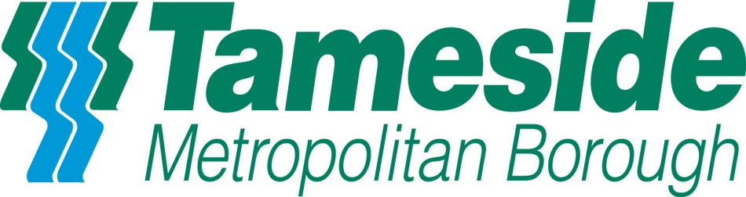

POLICY STATEMENT – FOR INFANT CREMATION – ENGLAND AND WALES

Tameside Council, Dukinfield Crematorium is committed to the sensitive and respectful care of all of those entrusted to us. Our policies and processes for infant cremation are aligned to the latest guidance on Infant Cremation, as per the recommendations of Lord Bonomy’s Infant Cremation Commission (June 2014 Scotland). Full statement here: http://www.gov.scot/Publications/2014/06/8342/3

In accordance with this guidance, which is fully supported by the national representative bodies, the Federation of Burial and Cremation Authorities (FBCA), the Institute of Cemetery and Crematorium Management (ICCM), the Cremation Society of Great Britain (CSGB) and the Association of Private Crematoria and Cemeteries (APCC) our ashes policy is set out below:

Definition of ashes
In line with Lord Bonomy’s recommendations, Dukinfield Crematorium considers cremated remains and ashes to be one and the same thing and supports the commission’s definition that ashes are “all that is left in the cremator at the end of the cremation process, and following the removal of any metal.”

Return of ashes
Our approach to the cremation of babies and infants is designed to maximise the recovery of ashes. This includes the use of a cremation tray designed to retain ashes where practicable, and the maintenance of operational conditions that will minimise the loss of any ashes during the process of cremation.

We will employ best practice e.g. the use of specialist computer programmes and metal trays and our staff will be vigilant during the cremation process and if appropriate, will adjust operational conditions when necessary in order to protect the ashes of babies and infants and maximise their recovery.

We are confident that the equipment and processes adopted for infant cremation at Dukinfield Crematorium maximise the likelihood of recovering ashes. In any rare instance of non-recovery of ashes, we will conduct a review of the cremation process within 48 hours to understand why this is the case. The results of this review will be documented and contain details of any adjustments of our procedure deemed to be necessary, and will be available to next of kin/parent(s) if they wish to view these. We will adhere to our identification procedure that guarantees that the ashes resulting from individual cremations returned to parents are those of their baby.

Shared cremations
Where a shared cremation has been authorised, and hence ashes are not individually identifiable, we will take the same care throughout the cremation process, including steps to maximise the recovery of ashes, and will scatter/bury the ashes within the crematorium’s designated area. The location will be recorded for future reference.

Disposal of Ashes
In relation to the disposal of ashes in the case of a private cremation, Dukinfield Crematorium will only act upon the written instruction of the parent who is acting as the Applicant for Cremation or other person nominated in writing by the parent.

In the case of shared cremations we will only act on the written instruction of the designated person at the relevant hospital, who is acting as the Applicant.

Ashes will be held at the crematorium for up to six weeks to await collection by representatives or instructions as to their disposal. Where no further instructions have been received within the six week period, a further fourteen days’ notice will be given in writing to the Applicant, following which the ashes will be scattered or buried within the grounds of the crematorium should no further instructions have been received.

Disposal of Metals – The applicant should give consent for disposal of metals recovered from an individual cremation and must be provided with information on the options available.

Record-Keeping
All cremations of babies and infants will be registered at the crematorium; with all information as contained in forms and certificates being retained indefinitely (This may be in electronic form).

If ashes are scattered or buried within the grounds of the crematorium the final resting place will be recorded. Where ashes are to be collected, the details of any person authorised by the applicant to remove/collect the ashes, and the date on which the ashes were collected will be recorded.

The policy of this Cremation Authority is designed to provide an audit trail from the receipt of initial funeral instructions to the final disposal of ashes, either by collection from the crematorium or by scattering or burial within the confines of the Gardens of Remembrance or other such designated area.

Questions or Queries

If you have any questions or queries about the cremation of your baby, you can speak to a Bereavement Officer by calling into Dukinfield Crematorium, Hall Green, Dukinfield SK16 4EP or Telephone 0161 342 4461

